Chapter 6 – Channels

A braided river in central Alaska cuts through boreal forest and tundra, its gravel-rich channel stands out from the dark vegetation. Photo by D. Montgomery. GEOMORPH0000000830
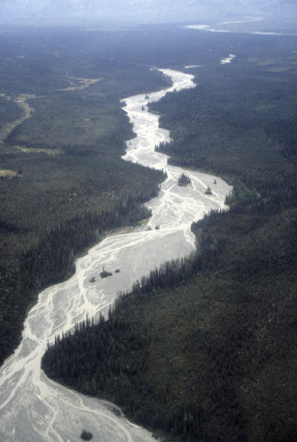

Introduction
Fluvial Settings and Drivers
Regional Setting
External Controls
Fluvial Processes
Flow Velocity
Discharge Variability
Sediment Transport
Channel Migration
Fluvial Morphology and Landforms
Valley Segment Types
Channel Patterns
Channel-Reach Types
Large Organic Debris
Floodplains
Channel response
Changes in Discharge
Changes in Sediment supply
Vegetation Change
Dams and Levees
Debris Flow Disturbance
Applications
Introduction
Streams drain landscapes and carry material from erosional uplands to depositional lowlands, estuaries, and coastal environments. Stream channels range in size from small headwater rivulets to large, continent-draining rivers, and they are shaped by water, sediment, and organic matter shed from hillsides and eroded from valley bottoms. Without rivers and streams to carry debris away, upland slopes would gradually become buried beneath their own waste as mountain valleys choked with sediment. An understanding of fluvial (river) processes and dynamics is thus central to studies of landscape evolution, from the processes that control local deposition and erosion of sediment and allow rivers to migrate across valley bottoms and form floodplains, to those that govern the way rivers incise into bedrock and generate the topography of upland valleys.
The interaction of flowing water and sediment shapes channels, so the supply of water, sediment, and large organic debris (logs) greatly influence channel morphology and dynamics. These factors vary within drainage basins, across regions, and over time, and channels exhibit tremendous variability in morphology and have dramatic responses to changes in discharge and sediment load. The physical processes that determine channel morphology and dynamics are similar across different regions but the importance of local controls and the influence of the downstream routing of water and sediment lead to a wide variety of channel types. Over long periods of geologic time, channels respond to tectonic uplift and subsidence, sea-level rise and fall, erosion of the landscape, and changes in climate and vegetation. Over shorter time scales, channels adjust and re-equilibrate to seasonal, annual, and decadal cycles of discharge and sediment supply as well as to changes in land use and extreme events like droughts and floods.
Long and short-term controls on fluvial morphology and processes both act to shape habitats for aquatic organisms. River dynamics influence the distribution of species along river corridors, and riparian (near-stream) areas are the most biologically diverse parts of many landscapes. Unlike terrestrial species that can migrate overland, aquatic species are constrained to the channel network and can only migrate up or downstream.
Stream channels respond to changes in the inputs of water, sediment, and wood and to direct physical manipulation of their form. Moreover, channel networks receive sediment shed from their watershed and are sensitive to changes in upstream land use. Throughout historical times, rivers around the world have experienced substantial changes as they have been dammed, straightened, pinned between levees, and cleared of logs and logjams. Modern channel restoration and flood control efforts are based on an understanding the ways that environmental controls, the history of human modifications, and physics interact in particular rivers. This chapter addresses the influences of regional landscape context on stream systems, explains the flow and transport processes that move water, sediment, and organic debris through channel networks, introduces the fluvial landforms that result from the action and interaction of these processes, and describes channel response to common changes in these processes.

Fluvial Settings and Drivers
Stream channels are subject to the physical laws of conservation of mass and energy. They are shaped by the sediment loads they carry, the cohesion of the material in their banks, the slopes they flow down, and the rocks they cut into. Recognizing the ways in which channel processes and dynamics influence fluvial landforms requires an appreciation of the effects of frequent, event-driven erosion and sedimentation, as well as the longer-term behavior of rivers and streams. Coupled with knowledge of where and how sediment is produced, understanding of fluvial processes is useful for evaluating how sediment is transported through channels, and where it is temporarily stored on its way down to the ocean. Regional and local controls on fluvial processes also provide essential context for interpreting river morphology and predicting channel response to environmental change.

Regional Setting
Regional climate and tectonic setting together broadly determine whether streams flow through steep or gentle terrain, and whether channels carry low or high loads of small or large sediment. Climate establishes the amount, type, and seasonal pattern of precipitation and runoff, and controls the dominant runoff generating mechanisms and thereby streamflow magnitude and variability. The depth to the water table influences whether channels carry flow only during storm runoff, or also as baseflow during periods between storms. Channels in arid and semi-arid regions may be ephemeral and flow for only part of the year, while perennial channels typical of humid or temperate regions flow year round. The potential for intense thunderstorms over small areas makes flash floods an important (and dangerous) fluvial process in semi-arid landscapes like the American Southwest. Ice jams that form in floods during spring ice breakup are an important fluvial process in places like New England and the northern Great Plains of North America where rivers annually freeze over (Photo 6-1). In general, regional climate is the dominant influence on the timing, magnitude, and regularity of the streamflows that control channel processes.
Regional tectonic forces generate uplift that elevates the land surface as well as subsidence that lowers the topography over which streams flow and into which they incise channels. Over geologic time, streams regrade their channels and influence the slopes of their own bedrock channels. Over shorter time frames, however, channel slope is an externally imposed factor that controls channel processes, particularly the flow of water and sediment transport. Regional geologic and tectonic history also determines the rock types (lithologies) over which streams flow and that influence processes of bedrock erosion, as well as the durability of the sediment that streamflow carries.
Steep channels incised into bedrock in tectonically active mountains differ greatly from lowland rivers that flow across depositional basins where sediment accumulates and can be stored over long periods of time. Upland bedrock channels tend to have little sediment cover, little alluvial storage in their valley bottoms, and typically have bedrock beds and/or banks. In contrast, lowland alluvial channels typically have a bed and banks composed of material transported by the channel and store substantial amounts of sediment in their valley bottoms. Mountain (bedrock) streams generally have a transport capacity that exceeds their sediment supply, whereas lowland (alluvial) streams have a sediment supply that equals or exceeds their transport capacity.

External Controls
Some factors that influence streams, including regional climate and tectonics, are externally imposed controls to which channel processes must respond. Other factors, like the pattern of erosion and deposition within a stream valley, are themselves influenced by channel response. As an example of the feedback between external controls and channel processes, consider how any net difference in erosion or deposition leads to changes in channel slope. If sediment supply exceeds a stream’s transport capacity, additional deposition will cause channel aggradation that increases channel slope and thereby increases the transport capacity. Conversely, if a channel's transport capacity exceeds its sediment supply, erosion will scour the channel bed, potentially down to bedrock, which will reduce the channel slope and reduce its transport capacity. In this context, a graded stream is one whose profile is adapted to carry its load. A graded stream profile is concave up, with steeper channels in headwaters declining progressively to reach the outlet of the river network.
Upland slopes deliver water and sediment to stream channel networks in varying ways and amounts, and over different periods of time. Streamflow sorts and transports this material, and shapes channels in response to external and self-limiting controls. Fluctuations in water flow and sediment supply give rise to spatial and temporal variability in channel morphology, processes, and response. The shape and behavior of a channel is governed primarily by its sediments, its discharge, the composition of its bed and banks, and the vegetation growing in the stream and on its banks. Many of these factors interact in complex ways with human modifications like dams and levees that impose new external controls on a channel or stream system.

Discharge
Discharge is the volume of water flowing past a point along a stream per unit time (Figure 6-1). Stream discharge (Q) is typically measured in cubic meters (or feet) per second, and is equal to the product of the channel’s cross-sectional area (A), and the flow velocity (V), or to the product of the stream width (W), mean flow depth (D), and mean flow velocity:
Q = A • V = W • D • V (6-1).
Discharge stays the same downstream unless water is added or lost, but velocity (measured in meters or feet per second) varies as the cross-sectional area of the flow varies. As you would expect, discharge remains constant along the course of a stream except where two tributary streams come together at a confluence, the channel splits into multiple distributaries, or water is gained from or lost to groundwater. The discharge values for successive stream segments are thus approximately equal (i.e., Q₁ = A₁•V₁ ≈ A₂•V₂ = Q₂), and if the stream widens, the flow will become shallower or faster — or both to lesser degrees. If the streambed narrows, the flow will become correspondingly deeper and/or slower. Consequently, along any particular stretch of river, shallow segments tend to be fast, while deep reaches tend to be slow. This is why when looking for a stream crossing one generally may expect to find the shallowest water where the surface flow appears fastest.
The discharge in a channel varies over both event and seasonal time scales as individual storms and annual weather patterns deliver precipitation. In humid-temperate regions, discharge systematically increases downstream within channel networks because small channels converge to form larger ones, and because perennial streams in wet climates typically gain more water from groundwater aquifers than they lose to them. High discharge events mobilize large volumes of sediment and typically govern the processes that dramatically reshape channels. Channels adjust their morphologies to floods that overtop their banks, and in response to changes in the discharge regime that is imposed by the environmental setting. For example, a channel may widen or deepen in response to urbanization that generates increased discharges in a drainage basin.
Not all the water associated with a stream flows above ground. The subsurface component of flow along stream corridors, called hyporheic flow, sometimes accounts for a substantial portion of streamflow, and can be ecologically important for riparian ecosystems. Channels often exchange substantial flow with permeable sediments within the stream valley, a common feature of gravel-rich mountain streams and floodplains in general.
The frequency, magnitude, and duration of high flows vary with seasonal patterns of precipitation and temperature. Some stream systems experience regular, predictable flood events, including those in regions with monsoon climates, streams dominated by seasonal melting of snowpacks or permafrost, and high-latitude rivers that flow pole-ward and experience massive ice-jams when they thaw upstream while downstream reaches remain frozen. In most regions, however, irregular storm-driven rainfall events like hurricanes and local intense thunderstorms produce variable-magnitude flows at less predictable intervals. Channels in regions that are subject to rain-on-snow events during which warm winds rapidly melt a snowpack in combination with heavy rainfall can experience exceptionally high discharges and flooding.
The way stream channels and their valleys carry high discharges greatly affects channel morphology and valley bottom landforms. High discharge events in mountain channels confined between bedrock valley walls have greater flow depths, for the same discharge, than do channels flowing through wide valley bottoms across which floodwaters disperse. This fundamental difference in how channels convey high flows leads to the common observation that there is typically very little sediment stored in mountain valleys and there is generally extensive deposition in alluvial lowlands.

Sediment Supply
The sediment supply to a channel is imposed by the rate at which material is delivered from upstream channel reaches, from neighboring hillsides, and from bed and bank erosion during channel incision and migration (Figure 6-2). The volume, grain-size, and degree of sorting of sediment supplied to a channel determines how much the stream flow is able to subsequently transport and sort, and how much it is unable to move and must work around. Sediment supply often varies tremendously over time, because hillslope processes generally deliver much greater volumes of sediment during abrupt events like landslides and intense erosion by overland flow during large storms than they do from slower, steadier processes like soil creep. In mountain drainage basins, sediment supplied by hillslope processes typically dominates the sediment supply to stream channels (Photo 6-2). In contrast, the sediment supplied to lowland channels generally comes from upstream channels and local bank erosion (Photo 6-3). Grain size and degree of sorting of the sediment supply to a channel often profoundly influence sediment transport patterns, channel dynamics, and channel morphology of a stream. For example, steep channels that receive only sand from upstream bank erosion may rapidly transport their full sediment load, while comparable channels that receive a wide range of particle sizes from a landslide off a valley wall may develop a coarse surface layer of large clasts that only move during the highest flows, if ever.

Bed and Bank material
The materials that form the bed and banks of a river control the relative ease, or difficulty, of incising the channel bed, eroding into channel banks and mobilizing the sediment. The bed and bank material helps set the tempo and style of channel migration. Some channels are composed of cohesive materials that resist bank erosion, such as bedrock or clay, and some are made of easily eroded, non-cohesive materials, such as sand and gravel that are readily re-mobilized by the streamflow.
Alluvial channels have beds and banks that are predominantly made of alluvium, unconsolidated material that is transported and sorted by the flow (Photo 6-4). In contrast, streams with bedrock channels actively cut into rock and flow directly over bedrock or over a thin layer of alluvium (Photo 6-5). They typically occupy narrow valleys with rocky walls. Most bedrock channels are found in upland hills and mountains, but some occur in relatively gentle terrain that has undergone deglaciation, recent uplift or downcutting, or in places that have dramatic lithologic contrasts or a limited sediment supply. Alluvial channels are most common in lower-gradient stream valleys that are unconfined by valley walls and have thick alluvium that shields the bedrock from active channel incision and allows channels to migrate laterally across valley bottoms.
The grain size distribution of material carried by a stream is an important control on channel morphology, but it is often not reflected in the sediments that accumulate in the channel bed. Perennial streams generally sort the material they carry; coarser sediment collects in the channel bed beneath fast-moving currents, and finer grains travel farther downstream to be deposited in calmer water. Further sorting of the channel bed occurs during high discharge events that mobilize larger sediment grains. Boulders introduced into channels by landslides can be too large for even rare high flows to transport. Accumulations of such boulders sometimes form persistent obstructions to the flow, such as the debris flow deposits that create steep rapids where tributaries enter the Colorado River in the Grand Canyon. Streambed material in the ephemeral streams common in arid regions and at the upstream tips of most channel networks is generally less well sorted, lacks a surface coarse layer, and more closely matches the composition of the sediment supply when compared to the channel bed of perennial streams.

Vegetation
Riparian vegetation that grows along the banks of stream channels and large woody debris, namely logs, that are transported and stored within channels influence channel processes and dynamics. Bank vegetation strongly affects channel shape and bank stability. The roots of vegetation growing along channel banks help to stabilize banks by adding apparent cohesion to bank-forming materials (Photo 6-6). Large trees growing in floodplains or along channels provide substantial root reinforcement that stabilizes channel banks and reduces bank erosion. The stabilizing effects of root reinforcement are most apparent along small, shallow channels where roots penetrate the full depth of the channel bank. In larger channels, where roots only penetrate a portion of the bank depth, stream currents often undercut the banks and counteract or even overwhelm the stabilizing contribution of roots. Even then, however, root reinforcement generally retards the pace of bank erosion.
Riparian vegetation also provides a source of in-channel woody debris (logs or mats of sticks, leaves, and roots) that acts as both mobile sediment and forms stable logjams. Accumulations of woody debris that slow, block or divert stream flow influence patterns of streambed scour, deposition, and sediment transport at scales that range from a single pool scoured from a streambed when flow is forced around a large log jam, to long-term storage of water and alluvium deposits behind log dams in steep, bedrock-floored mountain channels. Fallen trees may also redirect a stream current into the channel banks, and set off new rounds of channel shifting and sediment remobilization. In general, streams in forests have channels that vary in width along their courses, while grassland streams have channels of more uniform width. In forested regions, the amount of organic debris supplied to a channel can be as fundamental a control on channel morphology, processes, and dynamics as the stream’s sediment or discharge regime.

Fluvial Processes
Knowledge of the basic processes of discharge and sediment transport is crucial for understanding river dynamics because these are the most important processes that interact to form channels. The ability of a stream current to erode, transport, and deposit sediment reflects the balance between driving and resisting forces. The shear stress exerted by water flowing over the channel bed provides the impetus for sediment entrainment and transport, and the shear strength of the bed and bank-forming materials resists erosion and movement of sediment. Flow velocity within a channel reflects a balance between acceleration of water and sediment by gravity, and dissipation of frictional energy along the channel bed and walls and by turbulence within the flow. The total load of a stream includes fine-grained sediment suspended within the flow, coarser sediment that slides, rolls and bounces along the channel bed, and the material dissolved in the flow itself.

Flow Velocity
The flow velocity (V) in a channel depends on the fluid driving force that is controlled by the flow depth and the slope of the channel (S), as well as the resisting force generated by the frictional resistance provided by the channel bed and banks, called roughness. Flow velocity is measured in meters (or feet) per second, but channel roughness cannot be measured directly because it includes the integrated resistance to flow from all irregularities of the channel bed and banks. The overall roughness of a channel reflects the resistance caused by obstructions that protrude into and impede the flow, including bed-forming sedimentary particles, clusters of particles, and bedforms.
The Manning roughness coefficient (n), is one commonly used empirical assessment of frictional resistance that relates roughness to the average flow velocity (V) through
V = [R^{2/3} • S^{1/2}] / n (6-2),
where R is the hydraulic radius, defined as the channel cross sectional area (A) divided by the wetted perimeter (P). Note that when the equation is in feet, rather than meters, the numerator on the right hand side needs to be multiplied by 1.49 to account for unit conversion, because the equation is not dimensionless. Because the cross-sectional area is the product of width and depth (A=W•D), and the wetted perimeter is equal to W + 2D, the hydraulic radius R may be approximated as the flow depth (R ≈ D) in wide channels, where W >>D. Mannings n can be back calculated if the depth, slope, and velocity are known, but it is usually estimated from channel characteristics or using comparisons with channels of known roughness value. It is typical to assign a single value of n to a channel, but roughness values actually change over time because obstacles become submerged at high flow. Channel roughness actually decreases as the flow depth increases because friction on channel boundaries influences a smaller proportion of the flow. Flow velocities thus typically increase during floods.
Hydrologists have developed a number of methods to estimate flow roughness from channel characteristics. One popular technique is to compare a channel with pictures of channels of known flow depth, slope, and velocity for which the roughness has already been calculated. For example, U.S. Geological Survey Water Supply Paper 1849 shows an array of channels with known roughness values to which a channel of interest can be compared in order to arrive at a quick estimate of an appropriate roughness coefficient (Photo 6-7). Another method is to estimate roughness by consulting a table of channel characteristics (Table 6-1).
Bed and bank roughness that slows flow along the margins of a channel usually results in maximum flow velocity near the surface in the middle of the channel (Figure 6-3). Flow velocity increases from close to zero at the bed to maximum velocity immediately below the surface. (Flow at the surface is slightly slower because of the drag associated with the air-water interface). Flow immediately above the channel bed is typically characterized by a thin, viscous sub-layer, sometimes called the laminar sub-layer, where water molecules travel smoothly along parallel flow paths without interacting with or disrupting molecules in adjacent flow paths. Higher in the water column, the velocity increases logarithmically toward the maximum near the surface. Because of this non-linear increase, average flow velocity generally occurs at about 60% of the flow depth, and surface flow velocity typically provides an overestimate of average velocity. The convention among geomorphologists is to refer to the right or left bank of a channel as seen when facing downstream, looking in the direction of the flow.
Discharge is not uniform across a channel, so it is best measured by taking flow depth and velocity measurements at a number of locations (typically at least ten) across a channel and then calculating an average discharge value. Measurements of discharge and stage (water level height, easily converted to flow depth) taken at a range of flows over time define a rating curve (a plot of discharge versus stage) that allows for estimating flow discharge at different water levels. Once a rating curve has been constructed for a channel, discharge can then be estimated by simply measuring the flow stage, a process that can be automated using pressure transducers.

Turbulence
Open channel flow may be steady with constant velocity, or unsteady, with velocities that fluctuate in magnitude. Although open-channel flow in the real world is invariably characterized by unsteady, non-uniform flow, the equations used to analyze flow in natural channels are based on the assumption of steady, uniform flow. Nonetheless, simple flow equations are useful for representing and predicting general aspects of channel behavior.
Most natural channels exhibit turbulent flow in which the velocity continuously fluctuates, and produces eddies that mix the flow and greatly increase the flow resistance. It is clear after spending a few moments contemplating a rushing stream, that flow within natural channels is almost always turbulent. Turbulent flow can be tranquil, critical, or supercritical, and these different types of flow (defined below) determine what kind of bedforms develop on the channel floor. The specific type of flow that occurs can be calculated using the Froude Number (Fr), defined as the ratio of the flow velocity (V) to the speed of at which a surface wave will propagate, as given by the square root of the product of flow depth (D) and gravitational acceleration (g):
Fr = V / (D • g)^{0.5} (6-3). Tranquil, or sub-critical, flow happens when Fr < 1, during critical flow Fr ≈ 1, and super-critical is when Fr > 1. Basically, the Froude number indicates whether the water is moving faster or slower than its own wake, so a simple test for the difference between sub-critical and supercritical flow is to toss a rock into the stream. If the ripple from the splash travels upstream against the current, then the current is sub-critical. But if the current sweeps the expanding splash downstream, then the flow is super-critical. At critical flow, the upstream expansion matches the downstream flow, producing a standing (or stationary) wave. These three flow regimes transport and deposit sediment differently and are related to development of distinctive bedforms on the floors of channels.
Curiously, Froude numbers are also important in ship design. When ships go fast they can override up their own bow waves because they are pushing the water forward faster than it moves out of the way. That uses up far too much of the ship's energy, so shipbuilders use the Froude number, with hull length substituted for flow depth, to ensure that the ship is long enough to avoid the problem.

Discharge Variability
Under normal circumstances, channels contain stream flows between storm events. Periodic flows that fill a channel to the point of overflowing are called bankfull flows (Figure 6-4, Photo 6-8). In channels with alluvial banks, the bankfull flow generally represents the discharge volume to which channel width and depth are adjusted. In temperate environments, bankfull flows with 1- to 2-year recurrence intervals are the main agents that shape channels and determine stream morphology. More extreme events do more work per event, but are too rare to dominate river development.
The frequency with which a channel experiences bankfull flow varies from several times a year in some humid environments, to once every few decades in arid landscapes. Channels in arid regions thus often reflect the lasting influence of past events. When discharge volume overfills channels, flood flows spill out over the channel banks and inundate valley bottoms. Larger floods are known by their respective recurrence intervals, for example the 20- or 100-year flood, that respectively correspond to discharges with a 5% and 1% chance of recurring in any given year based on prior flood records. These designations are simple statistical probabilities, so there is no assurance that a stream that had a 100-year flood last year won’t have another one next year. For planning and insurance purposes, the anticipated land area covered by the 100-year flood is commonly used to delineate the extent of flood-prone areas.
The effective discharge is defined as that which transports the most sediment. In perennial humid-temperate streams this often corresponds to the bankfull flow with a 1- to 2-year recurrence interval. In monsoon driven stream systems, the effective discharge corresponds to the monsoon-season base flow. In arid channel systems the effective discharge may have a much longer recurrence interval.

At-a-Station Hydraulic Geometry
The width, depth, and velocity of the flow within a stream all change as discharge increases or decreases. The way in which these factors change as the discharge increases over the course of variable flow events defines the channel's at-a-station hydraulic geometry. Accurate predictions of the flow velocities at high discharges are useful for flood planning, but measurements at low flow velocities don’t give reliable estimates of flood conditions because the roughness changes as flow depths increase.
A channel's at-a-station hydraulic geometry describes how its width (W), depth (D), and velocity (V) vary as discharge (Q) rises and falls (Figure 6-2). Hydraulic geometry is defined using three linked equations that describe how these factors increase with discharge through a given channel cross-section:
W = a Q ^{b} D = c Q ^{f} V = k Q ^{m} (6-4),
where a, c, and k are constants, and b, f, and m are exponents. Because discharge is the product of the flow width, depth, and velocity (Q=W•D•V), the sum of the constants must equal 1 (a+c+k=1), and the product of the exponents must also equal 1 (b•f•m=1). Flow depth at a particular channel cross section (at a station) typically exhibits significant proportional change as discharge increases, but channel widths are generally constrained by the stream banks. Consequently, increased discharge is mostly accommodated by increased flow depth and velocity. There is a wide range of b, f, and m values reported for at-a-station hydraulic discharge relationships (0-0.48, 0.30-0.57, and 0.22-0.55, respectively) that reflects differences in channel pattern and controls on channel cross-sectional form, for example whether the stream flows between alluvial banks or bedrock outcrops. Knowing the hydraulic discharge relationships for a location allows predictions of flow depths and velocities at all possible discharge values.

Sediment Transport
Most of a stream’s total energy is dissipated by friction and turbulence, so only a fraction is available to erode and transport sediment, but even so, streamflow is a key agent of sediment erosion, transport, and deposition on the continents. Although the physics involved in analyzing the movement of sediment in rivers is complex enough to have reportedly discouraged a young Albert Einstein from pursuing a career in physical geography, consideration of a simple force balance acting on particles within the flow and on the stream bed actually provides substantial insight into how rivers transport their sediment loads. The processes of sediment entrainment, transport, and deposition govern the sorting of material in transport, development of systematic patterns of channel morphology, and formation of channel bedforms.

Shear Stress
Water flows downhill in a channel under the influence of gravity (Figure 6-5). The ability of streamflow to displace or erode the material in its bed, whether to transport sediment or incise bedrock, is due to the shear stress (τ):
τ = ρ • g • D • sinθ (6-5),
where ρ is the density of water, g is gravitational acceleration, D is flow depth, and θ is the channel slope. The flow depth is location-specific and is typically an average value. For the small angles typical of river beds, sinθ ≈ tanθ, and geomorphologists commonly adopt this small angle approximation for applications in low-gradient channels. This means that τ ≈ ρ g D tanθ, where tanθ is simply the drop in elevation divided by downstream distance for a given channel segment.

Forces Acting on Sediment
In addition to shear stress, the flow of water over sediment particles also exerts lift and drag forces that act to drive transport (Figure 1-11). The submerged weight of the particles and the frictional resistance between neighboring grains acts to resist transport. The frictional resistance is characterized by the friction angle of the bed-forming material, defined by the pivot angle necessary to rotate a grain up and over the adjacent grain. The degree to which a grain protrudes into the flow and its surface exposure to the flow influences the drag forces acting on the grain. When the driving forces exceed the resisting forces, sediment begins to roll along the streambed or is thrust up into the flow where it is carried along and settles at a velocity that depends on clast size and density. Upward directed velocity fluctuations keep small particles suspended in the flow while larger clasts roll, slide along the bed, or bounce before they settle back to the bed. Flow velocity increases rapidly above the bed, so sediment tends to move downstream once it is entrained in the flow.

Initiation of Motion
Entrainment of material from the streambed is necessary to initiate bedload transport. Resistance to motion depends on the size, shape, and density of sediment particles, their interlocking relationship with neighboring grains, and their exposure to the flow. Although not all particles on a streambed are mobilized at the same times, streambed gravels generally mobilize at flow velocities that exceed a critical shear stress (τ_{c}) characterized by
τ_{c} = τ_{c}∗ • g • (ρ_{s} − ρ) • d₅₀ (6-6),
where τ_{c}∗ is the Shields parameter (also known as the dimensionless critical shear stress), ρ_{s} is the density of the sediment, and d₅₀ is the median diameter of the bed-forming grains. Because individual particles are locally mobilized when bursts of high velocity, turbulent flow sweep the bed and kick clasts up into the flow, initial motion is generally defined not by the motion of a single clast but rather by a less precise observation of general bedload mobility. Streambed mobility is usually analyzed using the median grain size because larger clasts that protrude above the bed protect their smaller-than-average neighbors from the flow. Shields parameter values are generally about 0.06 for gravel streambeds, but the value varies among different channels, a reflection of the relative degree of sorting and packing of the streambed material, and ranges from 0.03 for loosely packed gravel to 0.1 coarse, well-packed cobbles (Figure 6-6). Shields parameter values are generally much higher for cohesive, fine-grained sediments, like clay, that require greater shear stress to initiate bed mobility. Once the critical shear stress threshold is reached and streambed sediment is mobilized, bedload transport rates generally increase with increasing shear stress (Figure 6-7).
For grain sizes above about 1-2 mm, the critical flow velocity required to erode material from a riverbed increases with grain size and is similar to the velocity below which sediment will be deposited. For cohesive materials less than about 1 mm in diameter, the flow velocity required to erode material from the bed increases with decreasing grain size because of cohesion between grains of fine-grained material like silt and clay. The low erodibility of fine-grained sediment is in contrast with its high transportability once it is entrained in the flow, a distinction that means it is harder to erode fine sediment than it is to keep it in motion. Coarse-grains rapidly fall back to the stream bottom and transport of coarse material ceases at flow velocities close to those that entrained it in the first place. But once mobilized fine-grained particles tend to remain suspended in the flow, even at very low flow velocities. Because of this fundamental difference, sediment finer than sand tends to travel in suspension, while gravel and coarser sediment travels as bedload. Sand, however, travels either way in many river systems.

Sediment Loads
The sediment load of a stream consists of material dissolved in, carried within, or pushed along by the water flowing in a channel (Figure 6-8). The dissolved load consists of material contributed by chemical weathering and therefore reflects the weathering regime and solubility of the rocks within the drainage basin. A stream’s dissolved load is directly related to the discharge volume, though the percentage of the total sediment load that is carried as dissolved matter varies greatly among streams in different environments. Channels that drain low-gradient catchments dominated by chemical weathering, or that have large lakes acting as sediment traps, carry most of their load as dissolved matter. The Saint Lawrence River, which drains the Great Lakes, is a notable example. In contrast, stream systems that drain steep catchments in rapidly eroding, tectonically active settings, like the Himalaya, carry a high proportion of sediment grains, or clastic load. The relative amount of clastic load varies greatly among rivers, from less than 10% of the total load to over 90%, and averages about 75% for the world's largest rivers. Dissolved load comprises the rest of the load and likewise varies greatly, from 43 parts per million (ppm) for the Amazon to 853 ppm for the Colorado River, with a global average of about 120 ppm. Unlike the clastic load, the dissolved load has little effect on fluvial geomorphological processes and channel morphology. Dissolved constituents are, however, often critical for stream organisms and the health of downstream water bodies.
The suspended load consists of material fine enough to remain suspended by turbulence and is carried along at a velocity slightly slower than that of the water flow. For a grain to be held in suspension, its settling velocity must be lower than the upward component of the velocity field created by turbulent eddies. The suspended load of most rivers consists of silt and clay because the settling velocity of a particle depends on its density and the square of its radius — large particles settle out far faster than finer ones. Material fine enough to never settle to the bed, even during low flow, is called the washload. Like the dissolved load, washload is transported downstream at the velocity of the flow with no geomorphic effect.
Wood and other floating organic matter sometimes constitutes a substantial component of the overall load of material carried by a stream. Unsaturated wood is less dense than water and floats downstream essentially as washload. Saturated logs can sink and become part of the material forming the channel bed. In forested regions, extensive logjams can partially obstruct, dam and even divert streams. In some cases, the presence of a root ball on a large log can both raise the log’s center of mass off the bed enough to keep it from floating, and create enough drag to embed its end in the channel bed when pushed along by the flow. Logs large and/or waterlogged enough to form stable key members create obstructions to flow that can capture additional wood and anchor logjams. The transport and storage of logs and organic debris within stream systems can greatly influence channel morphology and dynamics in forested regions.
Bedload is material that is transported by rolling, bouncing and sliding along the channel bed. Part of the bedload travels through saltation, bouncing downstream in a series of hop-like motions as particles are picked up and carried short distances by the flow before settling back to the channel bed. The distinction between suspended load and bedload is gradational, and the size of material transported as either suspended load and bedload changes as the discharge volume and flow velocity rise and fall. For example, in many channels, sand moves as bedload at low flows but becomes part of the suspended load during high flows. Material moving as suspended load during high discharge events likewise settles to the streambed as a flood recedes. Gravel and coarser material generally travel as bedload in most rivers and streams, but even boulders can be temporarily suspended and moved downstream in large enough floods. The material that makes up a streambed generally consists of bedload material that is periodically remobilized and deposited by fluctuating stream flow. The suspended load is likely to stay suspended until it either ends up on a floodplain, river delta or lake floor, or settles out during waning discharge as a readily re-mobilized layer that blankets the bedload material until the next high flow. This can be seen in patches of sand on bar tops along many gravel riverbeds.
Suspended load is easily, albeit crudely, measured by simply collecting a sample of water and determining the concentration of sediment in it. Multiplying the sediment concentration by the discharge gives an estimate of suspended load transport rates. In contrast, direct measurement of bedload transport rates is extremely difficult because of temporal variability and because placing a sample on the streambed disturbs stream flow and bedload transport. However, there is the additional problem that it is usually neither safe nor feasible to collect samples during flood flows that mobilize coarse riverbeds. Clever ways to measure bedload transport include recessing open troughs in a stream bed that are cleaned out after high flows to measure sediment transport, and tracking the movement of of magnetically tagged particles as they move downstream. Where conditions and access allow, bedload can also be measured directly with a sampling device that resembles a sturdy butterfly net, tipped on its side at the end of a long pole (called an Elwha sampler). Placed flush with the streambed, material rolling into the net is retained in a trailing mesh bag.
In contrast to the dependence of washload and suspended load on the supply of material delivered to the channel (most channels are capable of carrying far more suspendable material than they actually receive), bedload conveyance in alluvial channels is limited by the transport capacity of the channel. Prediction of bedload transport rates from channel characteristics like slope, depth, or stream power, is complicated by the observation that rates of bedload transport vary greatly for similar hydraulic conditions in different channels. Consequently, the accurate prediction of bedload transport rates often requires calibration against field measurements. Bedload generally accounts for a minor portion of the sediment moved by rivers, typically amounting to 10% and reportedly up to as much as 30% of the total load, but it is an important factor in determining channel morphology as it forms the bed and banks.

Stream Power
The ability of a stream to transport sediment and carve into the underlying bedrock is related to its stream power (Ω), which is defined as
Ω = ρ • g • Q • S (6-7),
where ρ is water density, g is gravitational acceleration, Q is discharge, and S is channel slope. If the same discharge flows through a narrower channel, the deeper flow will exert greater force on the channel bed and therefore be capable of greater sediment transport or bedrock incision. Accounting for this effect by considering the stream power per square meter (per unit area) of the channel bed instead of the total stream power, leads to an expression for the unit stream power, ω = Ω / W, which is equivalent to the product of shear stress and flow velocity (i.e., ω = τ • u) and in which W is the channel width. In general, deeper, faster-flowing water has more energy available to transport sediment or incise into the channel bed.
Bedload transport rates (Q_{b}) generally increase with increasing discharge above the flow required to initiate bed mobility, as a non-linear function of either excess shear stress (τ - τ_{c}) or excess unit stream power (ω - ω _{c}):
Q_{b} = k • (τ - τ_{c})^{1.5} (6-8a)
Q_{b} = k • (ω - ω _{c})^{1.5} (6-8b),
where the coefficient k acts to scale the rate of transport to the channel being studied.

Bedforms
Streambeds are rarely smooth because erosion, transport, and deposition of sediment shape a variety of bedforms on channel floors that result from feedback between flow and sediment transport. Bars are large-scale, elongate bedforms that are often longer than the channel width and occur in many shapes and positions within channels. Some bars are relatively permanent features that form in local sediment storage zones where sediment accumulates during high flows (Photo 6-9). Stable bars commonly develop at channel bends, confluences, or logjams along otherwise mobile alluvial channel beds. Bedload particles move from one sediment bar to the next, and are temporarily stored there between bed-mobilizing flows. Gravel-bed and sand-bed channels have similar types of bars, but their suites of finer-scale bedforms differ, some are stable features while others are mobile and progressively advance downstream.
Flow over a channel floor of readily deformable material, like loose sand, produces a range of bedforms (Photo 6-10) that contribute substantial flow resistance and change with the flow depth. Plane beds and low-amplitude ripples commonly form in sandy channels at low flow velocities or when deep flow (Fr << 1) generates a flow regime near the channel bed with minimal bedform roughness. Dunes with wavelengths of 4 to 8 times the flow depth, and heights up to a third of the flow depth form at higher flow velocities and/or shallower flow depths (Fr < 1). When flow approaches critical velocities (Fr ≈ 1), dunes wash out and form an upper flow regime plane bed devoid of bedforms. Supercritical flow (Fr>1), at even higher velocities and/or shallower depths, produces standing waves that create anti-dunes that are like dunes but face upstream and migrate upstream if the current is not too fast. Similar suites of bedforms develop in coarser-grained channels at high discharges.
In addition to bars, a number of distinctive bedforms and erosional features commonly develop in channels with gravel beds. Pebble clusters, streamlined particle tails, and clusters of coarse clasts aligned with the flow direction accumulate in the downstream lee of flow obstructions. Transverse-to-flow ribs that consist of repeated ridges of coarse clasts at a spacing determined by the largest clasts develop in areas of supercritical flow. Larger, stair-like gravel steps sometimes floor steep gravel channels, and channel-spanning steps of coarse clasts are common in cobble/boulder channels. Erosional bedforms like flutes, steps, and potholes also develop on cohesive, erosion-resistant channel bed surfaces.

Bed Armoring
In perennial channels, a coarse-grained surface layer generally forms from winnowing of the bed surface during non-flood flows between bed-mobilizing events. This coarse surface layer typically extends down about twice the median surface particle diameter, and overlies finer material that is more characteristic of the total bedload grain-size distribution once the bed surface is mobilized. Ephemeral channel beds in semi-arid regions generally lack this coarse surface layer because they lack day-to-day flows that are capable of sorting and winnowing particles between flood events, and because abundant sand precludes formation of a gravel armor in most locations.

Bedrock Incision
Channel incision into bedrock requires mobilization of the alluvial cover to expose the underlying bedrock to erosion. There are different erosional thresholds for entraining alluvial material and for incising into bedrock. In general, it takes more discharge, shear stress, and/or stream power to cut down into bedrock than to move sediment, so channel incision occurs only once both thresholds have been reached (Figure 6-9). In many cases, non-flood flow and frequent, smaller floods drive sediment transport processes, while larger, less-frequent events control channel incision into bedrock.
Stream flow incises into bedrock through a combination of abrasion, plucking, and dissolution, and the relative importance of each process depends on the bedrock type and stream morphology. Abrasion is essentially sandblasting of bedrock by material entrained in the flow that carves channels and sculpts rock into polished bedforms like potholes and flutes (Photo 6-11). Flowing water also loosens and plucks material from the beds of channels. Loose or broken rocks along fractures, joints, or bedding planes are particularly susceptible to plucking during floods (Photo 6-12). Hydraulic wedging of sand and gravel into openings helps loosen bedrock and make it susceptible to plucking. Streams also dissolve their way down through bedrock in regions with soluble rock, particularly limestone landscapes in humid climates where extensive dissolution leads to development of karst terrain. Dissolution often preferentially enlarges fractures or jointing in channel-bed rocks, which in turn promotes plucking. Thick sedimentary cover serves to protect the bedrock beneath a streambed from erosion. A low sediment load provides few tools entrained in the flow to erode exposed bedrock. The highest rates of bedrock incision thus occur in channels with intermediate sediment loads.

Channel Migration
Water flowing around channel bends, called meanders, determines in-channel patterns of sediment erosion and deposition and drives channel migration in alluvial channels. As flow enters a bend, the centrifugal force elevates the water surface on the outside of the curve. This super-elevation sets up a cross-channel component to the water surface slope that produces a secondary cross-channel circulation that drives flow down the outer bank and back across the channel, creating helical flow that spirals downstream in a roughly corkscrew-like pattern (Figure 6-10). This secondary circulation results in a zone of converging flow that scours out pools along the outer bank of a bend, erodes the bank and deflects flow back across the channel. Divergent flow on the inside of the channel bend likewise results in local deposition that builds up a crescent-shaped point bar built from deposition of bedload, creating a topographic obstruction that steers flow back across the channel into the outer bank. Cutbank erosion on the outside of channel bends and point bar deposition on the inner bank drives progressive channel migration (Photo 6-13).
The deepest part of the flow, called the thalweg, follows a path through shallow riffles that connect deeper pools. During periods of low flow, riffles have steep water surface slopes and rapid flow, while pools have relatively flat water surface slopes and slower flow. So how are pools scoured out? In contrast to conditions at low flow, at high flow, the flow velocities and water surface slopes in the pools increase more rapidly than in the riffles, leading to a velocity reversal. At high flows, shear stress increases toward the downstream ends of the pools, scouring and transporting coarse bed material to be deposited in lower velocity riffles where shear stresses decline downstream. The maintenance of pool and riffle sequences requires that at high flow the shear stress and velocity in pools exceed that within riffles.
The combination of focused bank erosion on cutbanks on the outer bank, and deposition of point bars on the inner bank causes channel migration. Meanders expand outward toward the eroding outer banks, and point bar deposition fills the inside of the curve. In most cases, the rate of erosion on cutbanks matches the deposition rate on point bars, which then become buried by overbank deposition over time. This process of coupled cutbank erosion and point bar deposition promotes channel migration at a pace equivalent to the annual rate of bank erosion, which is controlled by bank erodibility, stream size, and flow velocity. In many channels, one can readily see evidence for this process of gradual channel migration in the progression of vegetation height (and age) away from the channel on the inner (point bar) side of meander bends (Photo 6-14).
The point of maximum bank erosion is often just downstream of the meander apex, which leads to the downstream migration of meanders. However, obstructions like bedrock outcrops in alluvial floodplains or along valley walls can block downstream migration and force upstream meanders to bunch up. Stable in-channel obstructions like boulders, ice dams, key member logs or logjams may also impinge on meander patterns.
In addition to gradual channel migration by cutbank erosion and point bar deposition, channels may suddenly move to a new position, a process called an avulsion. Typically this happens in places where ongoing lateral migration brings the outer banks of two adjacent meanders close enough to erode through and intersect one another. When the upstream side of a meander captures the downstream side, it cuts off the intervening loop and creates a loop-shaped slough, called an oxbow lake. In addition to meander cut off events, channels sometimes avulse when a flow obstruction like a logjam blocks the channel, and causes flow to spill over the streambank and carve a new channel across the floodplain or shift to an inactive, abandoned channel. Streams with multiple side-channels are thus common in forested terrain with ample supplies of woody debris large enough to create logjams capable of diverting flow. Stable logjams at the heads of diverted channels are often porous enough to allow some flow to continue to enter, creating high-quality, low-disturbance fish habitat.

Fluvial Morphology and Landforms
Channel morphology reflects the interplay of fluvial processes, and determines the routing of material through drainage basins, stream valley segments, and individual channel reaches. Distinct channel patterns and the morphologies of individual reaches arise from different balances between sediment supply and transport capacity, as well as from the bedrock structure, climate, and supply of large organic debris along the stream valley. In alluvial basins where structural influences are minimal to non-existent, broad differences in channel pattern arise from fundamental differences in sediment loads and the relative balance between sediment supply and transport capacity.

Channel Patterns
Rivers and streams have a number of characteristic channel patterns that reflect adjustment to differing discharge and sediment load. At the most fundamental level, stream channels are either single or multi-threaded, and follow either relatively straight or tortuous paths. The sinuosity of a river is defined in various ways, but a simple definition is the ratio of the channel length measured along the center of the channel to the straight-line distance measured down the valley axis (Figure 6-11). High sinuosity channels follow convoluted, twisting paths, and low sinuosity channels follow relatively straight paths. Sinuosity and channel pattern change from one reach to another downstream within a channel network as a result of local influences on sediment supply and discharge. Natural channels vary within a wide spectrum of patterns, but the simple distinction of straight, sinuous, meandering, braided, and anastomosing channel patterns provides a useful framework for understanding the processes that control channel morphology.
Different channel patterns arise from differences in bankfull discharge, gradient, sediment supply, and bank material. Braided channels with multiple low-flow branches of within a single high-flow channel occur on steeper slopes and with greater sediment loads than single-thread meandering channels (Figure 6-12). Cohesive banks favor development of meandering channels, while weak, non-cohesive banks favor development of braided channels. Local stabilization by vegetation or large organic debris leads to development of anastomosing channels that are split into multiple individual channels separated by stable, vegetated islands. Streams with highly erosion-resistant banks, such as bedrock canyons, often follow structural weaknesses like faults, joints, or sedimentary bedding planes. While it has long been argued that meandering channels within deeply incised bedrock valleys inherited their courses from past channels cut in higher (now eroded) alluvial surfaces, it now appears that meanders can form in bedrock channels even after they begin carving down into competent bedrock.

Straight and Sinuous
Straight channels with sinuosities ≈ 1 are relatively rare in natural streams because even very slight flow irregularities lead to deposition and accumulation of sediment in alternate bars that are successively positioned on opposite sides of the channel (Photo 6-15). Sinuous channels, those with sinuosities of 1-1.5, are quite common because as soon as even a subtle bar forms on one side of a channel, it steers flow coming from upstream toward the opposite bank, where the flow begins to excavate a pool as it impinges on and erodes the far bank. Flow returning across the channel is, in turn, directed into the opposite bank, leading to the development of another pool and bar downstream, and so on down the channel. This process leads to the development of a sequence of alternate bars and pools that promotes lateral channel migration and the growth of meanders through erosion of the cutbank. Most straight channels have erosion-resistant banks, follow structural controls like faults, or have been confined by engineered levees that prevent natural lateral migration.

Meandering
Meandering channels have sinuosity values ≥ 1.5, and generally have a single, deep, narrow channel with few islands (Photo 6-16). True to their name, they shift their position across valley bottoms by erosion of their outer banks around bends (cutbanks), and deposition of point bars on their inner banks. Unconfined meandering channels typically develop a meander wavelength (the distance from the apex of one bend to the next on the same side of the channel) equivalent to about ten to twelve channel widths, a relationship that is related to the physics of thalweg oscillation as water flows along an undulating channel. Pools are generally located on the outer banks of each of the two bends between meander apices, so pools are typically separated by an average distance of five to six times the channel width.
The radius of curvature, the radius of a circle that fills the arc of a meander, describes the tightness of a river bend. A small radius of curvature describes a tight bend. Feedback between flow through the bend and bank erosion typically leads to a radius of curvature between 2 and 3 times the channel width in meandering channels. In broad bends with a larger radius of curvature, the greatest shear stress on the outer bank occurs upstream of the meander apex, leading to preferential erosion that tightens the bend and decreases the radius of curvature. Conversely, in tight bends, where the radius of curvature is small relative to the channel width, the greatest shear stress and most intense bank erosion is downstream of the meander apex, which causes lateral migration that broadens the bend and increases the radius of curvature. Through such feedbacks, the typical form of meandering rivers represents an equilibrium adjustment to the coupled flow and erosion through channel bends.
Meandering streams are common today, but we have found no evidence in the rock record that they existed before the evolution of land plants about 400 million years ago. Fluvial sediments from older periods of geologic time record braided channel morphologies. Conventional wisdom holds that this is because of the effect of root strength on bank stability, and recent flume experiments that demonstrate the role of streamside vegetation in stabilizing meander formation support this hypothesis.

Braided
Braided channels are made of multiple, active threads within a broad, low-sinuosity, high-flow channel. A series of shallow, wide, low-flow channel strands that branch, diverge, and converge again form a distinctive braided pattern within the banks of a typical braided channel (Photo 6-17). The sediment bars that divide the flow into multiple strands are called braid bars. Braided channels generally are quite dynamic, and individual strands shift positions dramatically within the main channel, sometimes on a daily basis, as ephemeral patterns of deposition and erosion shift the sediment that makes up the braid bars. Erodible banks and a sediment load that exceeds the stream’s carrying capacity favor formation of braided channels, because these factors force the stream to flow around its own sediment at low flow. High slope, frequent variations in discharge, a high load of coarse sediment, and wide, shallow flow promote development of braided channels. Braided channels are commonly found downstream of glaciers and at mountain fronts with high sediment loads and steep channels.

Anastomosing
Anastomosing (or anabranching) channels exhibit a complex pattern of individual channels that bifurcate and rejoin to flow around relatively stable, typically vegetated, islands (Photo 6-18). Anastomosing channels are generally narrower, deeper, and have lower gradients than braided channels, but they migrate through discrete avulsions instead of by steady lateral channel migration. Cohesive banks that limit lateral migration, flood-prone discharge regimes, and mechanisms that promote local overbank flooding or channel blockage promote formation of anastomosing channels. In forested environments, the presence of large organic debris capable of forming stable logjams that locally split flow into multiple channels can result in an anastomosing channel pattern. Similarly, blockage of individual channels by logjams can trigger avulsions that shift flow from one channel to another, or cause flow to spill overbank and form a new channel.

Channel-Reach Types
A channel reach is a stretch of a channel that exhibits similar bedforms. The distribution of typical channel reach types within a stream system reflects differences in relative transport capacity, as determined by the ratio of sediment supply to a stream's transport capacity. At a fine scale, within individual channel reaches, the channel bed consists of groups of morphologically distinct bedforms, called channel units, which are typically up to several channel widths in length. Unique suites of channel units — bars, steps, pools, and riffles — define different types of channel reaches. Topography, channel slope, flow depth, flow velocity, and to some extent grain size together control formation of particular channel units. As described earlier, bars are accumulations of sediment within the channel, and steps are local accumulations that span the channel to create a stepped drop in the channel profile. Pools are depressions on the channel bed, and riffles (also called shallows, rapids, and runs) are areas of relatively shallow, fast flow with otherwise relatively featureless beds.

Colluvial Reaches
Colluvial reaches typically occur in stream valley segments in the headwater portions of channel networks (Photo 6-19a). Hillslope processes of mass wasting, soil creep, tree throw, and burrowing activity introduce colluvial sediment into upland channel reaches. Flow in the channel does not govern the formation of the valley fill because shallow flow and limited fluvial transport capacity are insufficient to significantly alter patterns of gravity-driven deposition. Bedload sediment in colluvial stream reaches is typically poorly sorted and includes finer grain sizes than proximal downstream alluvial channels. Bed-surface grain sizes generally increase downslope as stream flow begins to winnow the finest grains, and most colluvial reaches exhibit downstream coarsening. Grain size typically reaches a maximum at or near the downslope transition from colluvial to alluvial reaches. In steep colluvial channels, debris flows that deposit clasts too large for normal flows to move are a dominant sediment transport process, and coarse-bed channels are common. The downstream terminus of a substantial debris flow often coincides with a grain-size maximum in a mountain stream profile because of the role that debris flows play in the delivery of coarse clasts.

Bedrock Reaches
Bedrock channel reaches cut mostly into rock. They have little, if any, alluvial bed material or valley fill, generally lack floodplains, and are typically confined by narrow valley walls (Photo 6-19b). Bedrock reaches typically occur on steeper slopes than alluvial reaches within the same drainage basin. In general, bedrock reaches lack an alluvial bed because the stream's transport capacity is greater than its sediment supply, a discrepancy that results from a high slope, and thus high transport capacity, a low sediment supply, or a combination of both. Channels that are subject to scouring and/or deposition by periodic debris flow may alternate between bedrock, colluvial, and alluvial morphologies as they recover following disturbance. Channels in mountain drainage basins often exhibit mixed alluvial-bedrock reach morphologies that arise from fluctuations in local controls on sediment delivery, accumulation, and storage. For example, softer, more erodable rocks wear down faster, and create wider valleys with more local accommodation space for storage of alluvium in the valley bottom than more erosion resistant rock types.

Alluvial Reaches
Alluvial channel reaches have bedform morphologies that are predominantly formed by the interaction of flowing water and the sediment it carries. Several distinct channel reach morphologies punctuate a natural continuum of alluvial channel types that reflect variations in relative transport capacity.
Cascade reaches are characterized by longitudinally and laterally disorganized bed material, and their bedload typically consists of cobbles and boulders (Photo 6-19c). Flow in cascade reaches diverges and converges around individual large clasts that protrude into the flow, and generates turbulent flow that dissipates a substantial portion of the total flow energy. The largest clasts may only move every few decades, while smaller clasts are rapidly transported during more frequent flows. Cascade reaches generally have steep gradients, between 8% and 20%, large bed material grain sizes, and relatively shallow flow depths. Sediment transport in cascade channels tends to be supply limited, because the transport capacity generally exceeds the sediment supply.
Step-pool reaches are characterized by a series of discrete channel-spanning accumulations of large clasts that form coarse-grained steps between pools floored by finer-grained sediment (Photo 6-19d). The steps account for much of the elevation drop within step-pool reaches and they provide bed roughness that causes areas of turbulent flow that alternate downstream with tranquil flow through pools. Steps nucleate where large clasts accumulate in congested zones with high local flow resistance, and grow by trapping additional large clasts. Infrequent flood events that move large clasts typically form the framework of step-pool reaches, and finer sediment is transported over the steps and deposited in pools during more frequent, lower velocity flows. Step-pool reaches typically form at channel slopes between 4 and 8%. Like cascade reaches, they are generally supply limited.
Plane-bed reaches have relatively featureless channel beds that are mainly composed of riffles or rapids (Photo 6-19e). Although they share the same name, they are not to be confused with the upper and lower regime plane-bed morphology in sand-bed channels. Plane-bed reaches are distinguished from steeper cascade reaches by the absence of tumbling flow, and by their smaller grain sizes relative to flow depths. The largest clasts protrude through the flow in cascade channels; they are submerged even at low flow in plane-bed channels. The few pools in plane-bed channels typically form in eddies where flow has been forced around obstructions. Plane-bed channels are typically straight, they have slopes of 1 to 4%, and are floored by a coarse surface layer that becomes mobile at or near bankfull flow. Plane-bed channels represent a transitional morphology between steeper, supply-limited channels and lower-gradient, transport-limited channels. Consequently, they are often found between step-pool reaches and lower-gradient meandering channels. Plane-bed reaches are rare in forested mountain drainage basins due to the influence of large woody debris on forcing local pool and bar formation (see below).
Pool-riffle reaches consist of a laterally migrating sequence of bars, pools, and riffles, and are typical of meandering channels (Photo 6-19f). The bedforms in pool-riffle reaches are often relatively stationary features even though the bed-forming material that composes them is under constant flux. Development of alluvial bars requires a large channel width-to-depth ratio and small grains (relative to flow depths) that are readily mobilized by the flow. Pool-riffle reaches typically have gravel- to cobble-sized bedloads, slopes less than 2%, a coarse surface layer, and general bed surface mobility at flows approaching bankfull. Sediment transport in pool-riffle reaches tends to be transport limited, but bed surface fining and changes in bedform size or amplitude can adjust transport capacity to the sediment supply.
Sand-bedded channel segments, also referred to as dune-ripple reaches, have sandy, mobile beds and exhibit a succession of mobile bedforms that provide the primary flow resistance. Bedform type is determined by flow depth and velocity (Froud number, as described above). Sediment transport in sand-bedded reaches occurs at almost all discharge volumes, and transport rates are strongly dependent on discharge. Sand-bedded reaches are thus transport-limited channels.

Large Organic Debris
Large organic debris like logs and logjams create stable obstructions to flow and force flow convergence, divergence, and sediment impoundment in stream channels that results in formation of pools, bars, and steps. The morphologic effects of large organic debris depend on its volume, position, orientation, and size relative to channel dimensions. Large logs in small channels can be stable for decades, even centuries, and force local, long-term flow convergence that scours out pools and flow divergence around hydraulically sheltered spots where sediment accumulates to form bars (Photo 6-20). In larger channels, individual logs are more mobile and less likely to obstruct flow, but groups of logs and other organic debris form stable logjams that influence pool formation, channel patterns, and sediment storage (Figure 6-13).
Stable logjams obstruct and divert flow and can split flow into multiple channels, forming anastomosing channel patterns. In forest channels, large organic debris can force the formation of pool-riffle or step-pool morphologies in reaches that would otherwise have bedrock or plane-bed morphologies. In such reaches, the abrupt failure or removal of a logjam, or a gradual reduction in the supply of wood large enough to form them, can lead to immediate dramatic changes in channel morphology. Deforestation and loss of a supply of large organic material can also permanently alter the morphology of a stream system.
Logs tend to float with their long axes aligned with the flow direction. If a log deviates from the flow path, the force of the flowing water acts to reorient it. Consequently, the length of a log relative to the radius of curvature of stream meanders matters for routing logs through a channel network. Long logs get hung up moving through tight river bends. The presence of a rootball enhances the stability of a log because the heavy, waterlogged wad of roots and soil digs into the bed and acts like an anchor as a log grounds out and begins to deflect flow. The types of trees that supply organic debris to a stream also influences the effect of floating plant material on stream morphology. The highly branched deciduous trees typical in temperate deciduous forests and tropical rainforests form individual snags that create substantial navigation hazards, as was the case on the historical Mississippi River and plagues boat traffic on tributaries of the Amazon today. In contrast, the telephone pole-like morphology of coniferous trees leads to extensive development of logjams, as material routed down river hangs up on large key members, as is common in the Pacific Northwest and in other evergreen forests around the world.

Floodplains
Floodplains occupy the low ground adjacent to a stream channel that has been built up by sediment deposited during frequent floods. Alluvial channels typically have laterally extensive floodplains that fill the stream valley to its lateral margins. Bedrock channels generally do not. Defining bankfull flow often is difficult in bedrock channels simply because they often have no discernable banks. Alluvial channels typically overflow their banks every year or two, and the depth and extent of floodplain inundation increases with the flood recurrence interval. Floodplains are built by lateral and vertical accretion of sediment that results from (i) deposition of suspended load that settles out from overbank flow, (ii) bedload deposition from lateral channel migration, and (iii) a composite of local surfaces formed by alluvium trapped by blockages like landslides, channel-choking plant growth, and log jams (Figure 6-14). These three processes lead to formation of different types of floodplains, composed of different materials and with different suites of floodplain landforms. Mapping active floodplains, and predicting the extent of floods with different recurrence intervals, like the 100-year flood, entails recognizing specific floodplain landforms.
When sediment-laden discharge spills out over channel banks during floods, the velocity of the unconfined flow quickly decreases, causing material carried by the flow to settle out onto the floodplain. Over time, sediment accumulates and builds up floodplains. Floodplains built up by the accumulation of suspended sediment are composed of landforms derived from differential settling of material leaving the river. As flow exits a swift-flowing channel to slow and mix with the water on the floodplain, the coarsest material settles out close to the channel, building natural berms parallel to the channel banks (Photo 6-22). Levees are high, sandy deposits along channel margins where the coarsest component of material suspended in the floodwaters settles out as high velocity flow leaves the channel and encounters lower velocity flow across an unconfined floodplain. Farther from the channel, floodplains built primarily of overbank deposition are composed of fine-grained sediment, typically silts and clays that were carried as suspended load. Extensive flooding can occur when rivers overtop their levees, because the surrounding floodplain typically sits at a lower elevation; backswamps commonly occupy low-lying ground on valley margins along suspended sediment dominated floodplains. Yazoo channels are tributary streams that flow down floodplains parallel to and outside of the main channel levees and that serve to drain floodwaters into the main channel at some distance downstream.
Bedload floodplains are built up by sediment deposited as a migrating channel moves across its valley bottom. Lateral channel migration by cutbank erosion on the outer side of meanders and point bar deposition on the inner bank builds floodplain deposits that are composed of relatively coarse-grained bedload material (old point bars and channel lags). Scroll bars are laterally stacked, abandoned point bar deposits associated with former positions of the inner margin of channel meanders (Photo 6-21). They record past positions of the stream channel and can be used to track its progress across a floodplain. Channel avulsions leave abandoned meanders that sometimes form oxbow lakes, narrow looping lakes connected to the main channel by tie channels. Oxbow lakes slowly fill with compactable clays that stud floodplains with erosion resistant masses that can obstruct lateral migration of future channel meanders, modifying groundwater flow paths, and unexpectedly disrupting bridge and building foundations.
In forested terrain, avulsions casued by local cahnnel damming by log jams can create networks of side channels. In addition, local accumulations of sediment trapped behind stable log jams and other obstacles to flow can coalesce into a patchwork floodplain composed of deposits at elevations determined by the depositional contexts of individual log jams. The resulting individual patches of bedload can form terrace-like surfaces at elevations up to several m above the riverbank. Unlike more conventional floodplain surfaces that have slopes similar to the valley slope, these flat surfaces that rise up to twice the diameter of the key member logs are discontinuous both laterally and longitudinally.

Channel response
Concern over impacts on human communities that rely on rivers and streams, as well as on aquatic and riparian ecosystems, motivates a desire to understand the ways that stream channel systems respond to disturbances, particularly those changes that result from human land use or climate change. The wide variety of channel types, the complex ways that channels adjust to local and regional factors, and the potential time lags between perturbation and response complicate interpretation and predictions of channel response. Channels respond to a wide range of influences over short and long time scales, from the effects of engineered dams and levees, deforestation, and fires on sediment delivery, to the effects of climate change and tectonics on basin hydrology, through crustal uplift and tilting, changes in regional precipitation patterns, and base level change.
Channel morphology adjusts to variations in sediment supply and discharge. In general, channels respond to fluctuations in (i) the delivery rate, volume and grain-size of their sediment supply, (ii) their transport capacity that is affected by variations in average discharge as well as the frequency, magnitude, and duration of high-discharge events, and (iii) vegetation that influences bank stability or the size, amount, and stability of in-channel woody debris. Channels alter their width, depth, bed slope, grain size, bedforms, and channel patterns to accommodate changes in these three primary forcing functions.
Changes in discharge or sediment supply are often offset by corresponding changes in grain size and slope (Figure 6-15), which can be formalized as a relationship that states that the product of the bedload supply (Q_{s}) and the bed surface grain size (d₅₀) is proportional to the product of the water discharge (Q) and channel slope (S):
Q_{s} • d₅₀ ≈ Q • S 6-9.
The sediment load (Q_{s}) and discharge regime (Q) are imposed on the channel, which is free to adjust grain size (d₅₀) or slope (S), sorting material and incising or aggrading to adjust the bed slope to transport the imposed load. While there are additional ways through which channels respond to changes in transport capacity, or sediment supply, this basic relationship provides a simple conceptual basis for investigating, interpreting, and predicting channel response. A channel that receives an increased sediment load, for example, may become steeper because the excess sediment is stored in the channel bed. The steeper slope, in turn, increases the bedload transport capacity, which speeds sediment transport. Channels respond to natural disturbances, like high rates of sediment delivery from landsliding during large storms, as well as to anthropogenic disturbances like the construction of dams and levees that alter sediment supply, discharge regime, or the potential for channel migration.
Despite the apparent simplicity of equation 6-9, channel response often involves a complex chain of adjustments that proceeds at different rates and styles in different parts of a watershed. For example, downcutting of a main river to accommodate a base level drop from falling sea level may lead to channel incision and terrace formation as channel incision migrates upstream, followed by renewed aggradation when high sediment loads from incision of upstream tributaries reaches the main channel. Different streams and stream segments within a drainage basin are thus often out of phase in their responses to the same initial impetus because of the time lags that arise from routing sediment through the channel network.

Discharge
Changes in discharge magnitude and frequency result from either changes in the precipitation falling within a drainage basin, or changes in runoff production from groundwater discharge, snowmelt, and flow routing through a channel network. Land use and management practices also affect the volume and timing of runoff delivered to channels. Urbanization of a drainage basin, for example, often dramatically increases peak discharges because increased impervious area reduces infiltration and causes more rapid runoff. Paving and storm water drainage systems installed during urban development sometimes result in dramatic changes in the recurrence interval of flood flows. Many studies have found that the pre-urbanization 10-year flood can become a 1 to 2-year flood after urbanization.
Channel response to changes in discharge volume typically involves channel widening and/or deepening to accommodate larger, more frequent flows. Changes in watershed vegetation also affect the discharge regime in downstream channels. Forest clearing, for example, generally increases discharge by reducing moisture uptake by trees. Changes to low-flow conditions may be very important biologically, as in the case of flow that maintains pools during dry summer months, but changes to non-flood conditions are generally unimportant in terms of channel morphological response. Increased peak flows that result from faster delivery of runoff from new roads and other pavement or from rain-on-snow events in newly cleared forest areas can trigger dramatic channel enlargement or incision.

Changes in Sediment supply
Changes in the sediment supply to a channel occur naturally when landslides and downslope mass movements suddenly deliver sediment from hillslopes into stream channels. Anthropogenic changes like those that accompany mining, logging, urban development, or land clearing for agriculture can also dramatically alter patterns of sediment supply to stream channels.
Aggradation occurs when an increased sediment supply overwhelms the local stream transport capacity and builds up the channel bed. Rapid addition of a large amount of sediment can result in significant channel infilling and loss of flow conveyance, which increases the frequency of overbank flood flows. Channel responses to an abrupt increase in sediment supply also include fining of the channel bedload, pool in-filling, channel widening, and development of channel braiding and longitudinal braid bars. Pulses of sediment introduced into channel systems may move down through channel networks as a coherent slug, causing a wave of progressive aggradation and re-incision as the sediment moves downstream. Patterns of sediment storage that are out of equilibrium with the stream system as a whole can persist for decades within a channel network as streamflow gradually mobilizes and redistributes sediment from the reaches where it accumulated. The impact of increased sediment loads can be long lasting. Channels in parts of the Sierra Nevada are still adjusting to the tremendous inputs of mining debris that occurred during California's Gold Rush in the mid 1800’s.
Channel responses associated with reduced sediment supply include both channel incision, or entrenchment, as occurs when people mine substantial amounts of gravel from a channel, and changes in the grain-size distribution and sorting of the channel bed sediments. Channels with a high sediment load tend to have finer beds lacking a distinct coarse surface layer, while those with low sediment loads generally have coarser beds and a well-developed coarse surface layer. An abrupt reduction in sediment supply, as occurs when a dam is constructed across a stream, typically results in channel incision and coarsening of bedload sediments.

Vegetation Change
Changes in riparian and in-stream vegetation also influence channel characteristics like the abundance of pools, bars, and steps generated by accumulations of woody debris. Alteration of channel margin vegetation changes the size and species of wood entering a channel. The conversion of channel margin vegetation from forest to grassland species can lead to systemic channel widening or narrowing, depending on the relative amount of bank reinforcement by roots. In general, however, in-channel logs and logjams recruited from streamside forests tend to promote variability in channel width by locally deflecting flow toward channel banks and eroding them. In forest channels, depletion or reduced size of large organic debris causes loss of pools, alluvial reaches to erode down to bedrock, and anastomosing channel patterns to simplify and become braided, straight or meandering streams. In small channels where logs and logjams provide significant sediment storage, a decreased supply of large wood accelerates sediment transport. Channels in which large wood provides a dominant control on pool formation and sediment storage, like those with a forced pool-riffle or forced step-pool morphology, are particularly responsive to changes in the size and amount of woody debris.

Dams and Levees
Dam construction and large natural stream obstructions like landslide deposits, logjams, lava flows, and glaciers, change both the discharge regime and the sediment supply of downstream channels. Channel incision and bed surface coarsening occurs immediately downstream of dams because the sediment formerly delivered from upstream is impounded behind the dam. Decreased discharge or frequency of high flow events below a dam causes channel narrowing in downstream reaches. Conversely, dam removal causes channel widening and leads to a sediment pulse that moves through downstream reaches as the stream redistributes the material that accumulated in the reservoir and regrades its channel.
The construction of levees along a river can exacerbate downstream flooding by preventing the spread of floodwaters across the floodplain and speeding flow to downstream reaches. When we look back at the history of many stream systems, it is common to see that once levees were constructed in one part of a basin, levees or other flood control structures were soon required on stream reaches throughout the floodplain. In locations where channel gradients decrease downslope, levee construction also results in deposition of material inside the channel because flow is confined within the levees and prevented from carrying enriching sediment over the channel banks and into the floodplain. This leads to dramatic aggradation of the channel bed and levees, and deflation of the floodplain surface as loose sediments compact under their own weight. Ongoing levee reinforcement over the past several thousand years along China's Yellow River (Huanghe) has led to the elevation of the channel of more than 100 feet above its floodplain. Today, this ensures a catastrophic disaster every any a levee fails.

Landslides
Landslides sometimes introduce material that is too large for a stream to transport, whether from rock falls, valley wall slides, or debris flows that displace very large volumes of material long distances down headwater channels in mountain drainage basins. Like dams engineered by humans, large landslides act to dam rivers, and impound lakes, but they typically erode away over time in the absence of human maintenance. As rivers erode down through landslide debris, the clasts that are too large to transport sometimes become concentrated and form an immobile lag on the channel bed retarding river incision.
The effects of debris flows vary with slope and position along the channel network. Debris flows can scour headwater channels to bedrock, and they generally deposit material when they reach slopes of 3-6° or lose substantial momentum traversing sharp bends at tributary junctions. Deposition of debris flows results in local aggradation because they abruptly deposit a large volume of material that includes clasts that the receiving stream cannot move. Sometimes debris flow deposits completely fill in and obliterate a channel. Recovery following debris flow disturbance differs between steep and low-gradient channels. Steep, high-energy channels (bedrock, cascade, or step-pool reaches) recover relatively quickly and rapidly transmit debris-flow material to downstream channels. In contrast, low-gradient channels (pool-riffle and plane-bed reaches) generally take longer to recover from debris flow impacts because of their lower transport capacity. The specific morphology of mountain channels that are prone to debris flows depends on the time since the last debris flow. The cycle of disturbance and recovery can take decades to centuries and vary with position in the channel network. Locations where tributaries deliver debris flow deposits to main channels sometimes develop stable rapids like the ones that thrill rafters along the Grand Canyon.

Applications
Human actions within drainage basins affect fluvial systems, often dramatically. In addition to direct impacts like channelization by levees and impoundment by dams, human modifications to the land surrounding a stream system that affect discharge and sediment supply, including deforestation, agricultural development and urbanization, also profoundly affect stream systems. Construction and paving of land in urban and suburban areas increases the area of impervious surfaces, which alters the volume and timing of runoff delivered to stream channels, often triggering channel adjustment. Indeed, subtle changes, like replacing hummocky forest micro-topography with smooth suburban lawns, can be enough to influence stream behavior. Increased sediment delivery to channels from agriculture and forestry practices, as typically accompanies plowing and clear cutting, alters sediment loads and forces streams to adjust.
In-stream structures, including dams, levees, and other flood control and flow modification structures, dramatically affect river behavior. The direct effects of such changes are easy to appreciate. Levees prevent channel migration, and dams store discharge and trap sediment. The indirect effects of changes on riparian and in-stream vegetation can be more difficult to identify, but are no less profound. These serious, secondary consequences include changes in stream gradient, redistribution and destruction of aquatic habitats, and variations in the flux of sediment and water through the stream corridor over time and space. Understanding how such changes influence particular river systems is fundamental to assessing and mitigating flood hazards as well as to understanding human impacts on aquatic resources, and designing or evaluating river restoration projects.
Rivers and streams are the conduits by which water and sediment move from continental uplands into the world’s oceans. In the long term, channels respond to tectonic, climatic, and biological influences by altering their gradients and morphology. Over shorter periods of time, channels are dynamic, and adjust to disturbances to sediment and water flux as well as to changes in riparian vegetation, by changing their depth, width, and shape. The relationship between different types of sediment transport processes and the resulting fluvial landforms shapes an understanding of fluvial processes that can guide the assessment of potential channel responses to changes in discharge and sediment regimes, as well as riparian (streamside) and in-stream vegetation, and woody debris.

Table 1. Typical Manning's n Values

Channel-bed material Manning's n
Straight canal/concrete banks 0.01-0.02
Straight canal/earthen banks 0.02-0.03
Sand 0.01-0.03
Sand / Gravel 0.03-0.05
Cobble / Boulder 0.04-0.07
Timber/vegetation choked 0.07-0.16
Selected References and Further Reading
Abbe, T. B., and Montgomery, D. R., 2003, Patterns and process of wood debris accumulation in forest channels, Geomorphology, v. 51, p. 81-107.
Andrews, E. D., 1980, Effective and bankfull discharges of streams in the Yampa River basin, Colorado and Wyoming, Journal of Hydrology, v. 46, p. 311-330.
Bagnold, R. A., 1973, The nature of saltation and of "bedload" transport in water, Proceedings of the Royal Society of London, v. 332a, p. 473-504.
Barnes, H. H., Jr., 1967, Roughness characteristics of natural channels, U.S. Geological Survey Water-Supply Paper 1849, U.S. Government Printing Office, Washington, D.C.
Brummer, C. J., and Montgomery, D. R., 2003, Downstream coarsening in headwater channels, Water Resources Research, v. 39, 1294, 10.1029/2003WR001981.
Buffington, J. M., and Montgomery, D. R., 1997, A systematic analysis of eight decades of incipient motion studies, with special reference to gravel-bedded rivers, Water Resources Research, v. 33, p. 1993-2029.
Callow, P., and Petts, G. E., (editors), 1992, The Rivers Handbook: Hydrological and Ecological Principles, Blackwell Science, Oxford.
Carling, P. A., and Petts, G. E., 1992, Lowland Floodplain Rivers: Geomorphological Perspectives, John Wiley & Sons, Chichester.
Constantine, J. A., and Dunne, T., 2008, Meander cutoff and the controls on the production of oxbow lakes, Geology, v. 36, p. 23-26.
Costa, J. E., Miller, A. J., Potter, K. W., and Wilcock, (editors), Natural and Anthropogenic Influences in Fluvial Geomorphology, Geophysical Monograph 89, American Geophysical Union, Washington, D.C.
De Waal, L. C., Large, A. R. G., and Wade, P. M., (editors), 1998, Rehabilitation of Rivers: Principles and Implementation, John Wiley & Sons, Chichester.
Dietrich, W. E., 1987, Mechanics of flow and sediment transport in river bends, in River Channels: Environment and Process, edited by K. Richards, Basil Blackwell, Oxford, pp. 179-224.
Dietrich, W. E., and Smith, J. D., 1983, Influence of the point bar on flow through curved channels, Water Resources Research, v. 19, p. 1173-1192.
Doyle, M.W., Stanley, E.H., Harbor, J.M., 2002, Geomorphic analogies for assessing probable channel response to dam removal, Journal of the American Water Resources Association, v. 28, p. 1 -13.
Dunne, T., Mertes, L. A. K., Meade, R. H., Richey, J. E., and Forsberg, B. R., 1998, Exchanges of sediment between the flood plain and channel of the Amazon River in Brazil, Geological Society of America Bulletin, v. 110, p. 450-467.
Emmett, W. W., and Wolman, M. G., 2001, Effective discharge and gravel-bed rivers, Earth Surface Processes and Landforms, v. 26, p. 1369-1380.
Ferguson, R. I., 2003, Emergence of abrupt gravel to sand transitions along rivers through sorting processes, Geology, v. 31, p. 159-162.
Gilbert, G. K., 1917, Hydraulic-mining debris in the Sierra Nevada, U. S. Geological Survey Professional Paper 105, Government Printing Office, Washington, D.C.
Gomez, B., and Church, M., 1989, An assessment of bed load sediment transport formulae for gravel bed rivers, Water Resources Research, v. 25, p. 1161-1186.
Graf, W. L., 1988, Fluvial Processes in Dryland Rivers, Springer-Verlag, Berlin.
Henck, A., Montgomery, D. R., Huntington, K. W., and Liang, C, 2010, Monsoon control of effective discharge, Yunnan and Tibet, Geology, v. 38, p. 975-978.
James, L. A., 1989, Sustained storage and transport of hydraulic gold mining sediment in the Bear River, California, Annals of the Association of American Geographers, v. 79, p. 570-592.
Knighton, A. D., 1989, River adjustment to changes in sediment load: The effects of tin mining on the Ringarooma River, Tasmania, 1875-1984, Earth Surface Processes and Landforms, v. 14, p. 333-359.
Knighton, A. D., 1998, Fluvial Forms and Processes: A New Perspective, Arnold, London.
Kodama, Y., 1994, Experimental study of abrasion and its role in producing downstream fining in gravel-bed rivers, Journal of Sedimentary Research, v. 64, p. 76-85.
Lane, E. W., 1955, The importance of fluvial morphology in hydraulic engineering, Proceedings of the American Society of Civil Engineers, v. 81, p. 745-761.
Leopold, L. B., 1968, Hydrology for Urban Land Planning: A Guidebook on the Hydrologic Effects of Urban Land Use, U.S. Geological Survey Circular 554, 18p.
Leopold, L. B., and Maddock, T. Jr., 1953, The Hydraulic Geometry of Stream Channels and Some Physiographic Implications, U.S. Geological Survey Professional Paper 252, 56p.
Leopold, L., B., and Wolman, M. G., 1960, River meanders, Geological Society of America Bulletin, v. 71, p. 769-794.
Leopold, L. B., Wolman, M. G., and Miller, J. P., 1964, Fluvial Processes in Geomorphology, W. H. Freeman, San Francisco.
Mackin, J. H., 1948, Concept of the graded river, Bulletin of the Geological Society of America, v. 59, p. 463-512.
Madej, M. A., and Ozaki, V., 1996, Channel response to sediment wave propagation and movement, Redwood Creek, California, USA, Earth Surface Processes and Landforms, v. 21, p. 911-927.
Milliman, J. d., Yun-Shan, Q., Mei-E, R., and Saito, Y., 1987, Man's influence on the erosion and transport of sediment by Asian rivers: The Yellow River (Huanghe) example, Journal of Geology, v. 95, p. 751-762.
Montgomery, D. R., and Abbe, T. B., 2006, Floodplain and terrace formation in an old-growth forest valley, Queets River, Washington, Quaternary Research, v. 65, p. 147-155.
Montgomery, D. R., and Buffington, J. M., Channel-reach morphology in mountain drainage basins, Geological Society of America Bulletin, v. 109, p. 596-611, 1997.
Montgomery, D. R., Abbe, T. B., Peterson, N. P., Buffington, J. M., Schmidt, K. M., and Stock, J. D., 1996, Distribution of bedrock and alluvial channels in forested mountain drainage basins, Nature, v. 381, 587-589.
Murray, A. B., and Paola, C., 1994, A cellular model of braided rivers, Nature, v. 371, p. 54-57.
Nanson G. C. and Croke, J. C., 1992. A genetic classification of floodplains, Geomorphology, v. 4, p. 459–486.
Parker, G., 1976, On the cause and characteristic scales of meandering and braiding in rivers, Journal of Fluid Mechanics, v. 76, p. 457-480.
Petts, G. E., and Amoros, C., (editors), 1996, Fluvial Hydrosystems, Chapman & Hall, London.
Petts, G. E., Möller, H., and Roux, A. L., 1989, Historical Change of Large Alluvial Rivers: Western Europe, John Wiley & Sons, Chichester.
Pizzuto, J. E., 2002, Effects of dam removal on river form and process, BioScience, v. 52, p. 683-691.
Richards, K. S., 1982, Rivers, Methuen and Co., London.
Russell, I. C., 1898, Rivers of North America, G. P. Putnam's Sons, New York, John Murray, London.
Schumm, S. A., 1977, The Fluvial System, John Wiley and Sons, New York.
Schumm, S. A., 2005, River Variability and Complexity, Cambridge University Press, Cambridge.
Schumm, S. A., Mosley, M. P., and Weaver, W. E., 1987, Experimental Fluvial Geomorphology, John Wiley & Sons, New York.
Stover, S. C., and Montgomery, D. R., Channel change and flooding, Skokomish River, Washington, Journal of Hydrology, v. 243, p. 272-286, 2001.
Summerfield, M.A., and Hulton, N.J., 1994, Natural controls of fluvial denudation rates in major world drainage basins, Journal of Geophysical Research, v. 99, p. 13871-13883.
Tal, M., and Paola, C., 2007, Dynamic single-thread channels maintained by the interaction of flow and vegetation, Geology, v. 35, p. 347-350.
Thorne, C. R., Hey, R. D., and Newson, M. D., 1997, Applied Fluvial Geomorphology for River Engineering and Management, John Wiley & Sons, Chichester.
Vörösmarty, C. J., Meybeck, M., Fekete, B., Sharma, K., Green, P., and Syvitski, J. P. M., 2003, Anthropogenic sediment retention: major global impact from registered river impoundments, Global and Planetary Change, v. 39, p. 169-190.
Whipple, K. X., Hancock, G. S., and Anderson, R. S., 2000, River incision into bedrock: Mechanics and relative efficacy of plucking, abrasion, and cavitation, Geological Society of America Bulletin, v. 112, p. 490-503.
Whipple, K. X., 2004, Bedrock rivers and the geomorphology of active orogens, Annual Reviews of Earth and Planetary Sciences, v. 32, p. 151-185.
Wiberg, P. L., and Smith, J. D., 1989, Model for calculating bed load transport of sediment, Journal of Hydraulic Engineering, v. 115, p. 101-123.
Wohl, E., 2000, Mountain Rivers, Water Resources Monograph 14, American Geophysical Union, Washington, D.C.
Wohl, E., Angermeier, P. L., Bledsoe, B., Kondolf, G. M., MacDonnell, L., Merritt, D. M., Palmer, M. A., Poff, N. L., and Tarboton, D., 2005, River restoration, Water Resources Research, v. 41, W10301, doi:10.1029/2005WR003985.
Wohl, E. E., and Merritt, D. M., 2001, Bedrock channel morphology, Geological Society of America Bulletin, v. 113, p. 1205-1212.
Wolman, M. G., and Leopold, L. B., 1957, River Flood Plains: Some Observations on their Formation, U.S. Geological Survey Professional Paper 282-C, 30p.
Wolman, M. G., and Miller, J. P., 1960, Magnitude and frequency of forces in geomorphic processes, Journal of Geology, v. 68, p. 54-74.

Photos
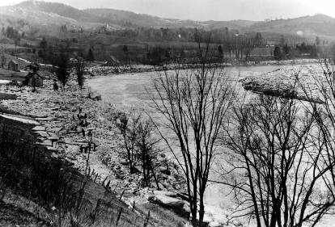
Photo 6.1 A spring ice jam along the White River in Sharon, Vermont has cleared but not before raising water levels sufficient to move large ice blocks out of the channel and onto the floodplain, covering a road and damaging several buildings. Photo from the Vermont Historical Society. LS07339_000.

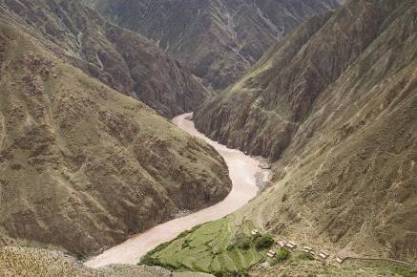
Photo 6.2 Sediment enters the turbid Salween River of eastern Tibet directly from steep, strength-limited slopes with little soil cover and no intervening floodplain. Photo by A. Henck. GEOMORPH0000001571.
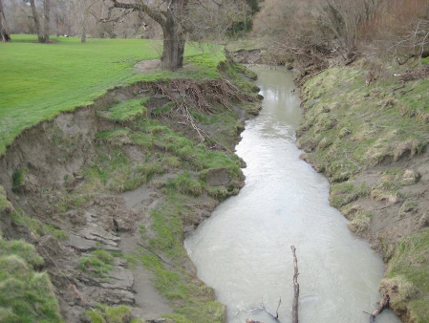
Photo 6.3 Bank erosion on small stream in the Waipaoa basin, North Island, New Zealand. Photo by P. Bierman. GEOMORPH0000000220.
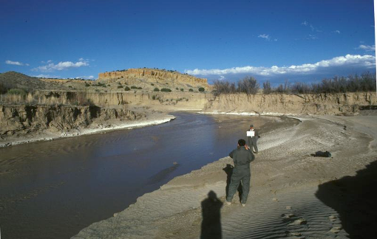
Photo 6.4 The Rio Puerco flows though alluvial sediments in northern New Mexico. GEOMORPH0000001232. [BAD PHOTO CLUB]
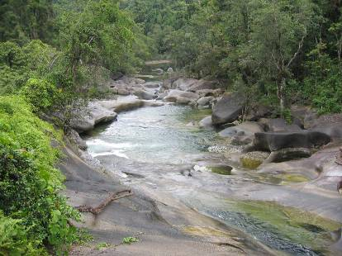
Photo 6.5. A river in Queensland, Australia is confined in a bedrock channel. Photo by P. Bierman. GEOMORPH0000000216.

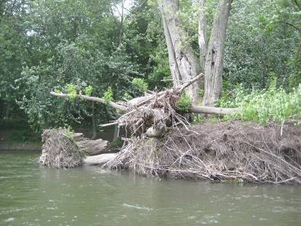
Photo 6.6 (A) Tangled root mats from Silver Maple trees hold together an alluvial mid-channel island in the Winooski River, Vermont. Flood debris (mostly wood) is jammed on the upstream side of the island. Photo by P. Bierman. GEOMORPH0000003982.
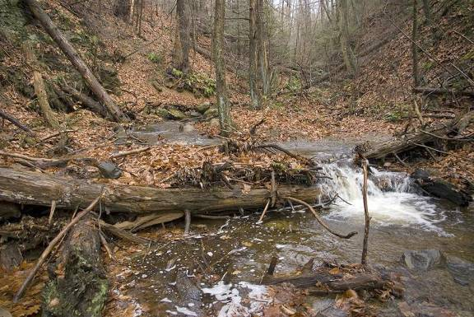Photo 6.6 (B). Large woody debris in small stream creates a log step changing local stream gradient and impounding water and sediment. Cobalt, Connecticut. Photo by D. Thompson. GEOMORPH0000001777.

A. n = 0.026  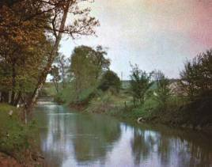 | B. n = 0.036  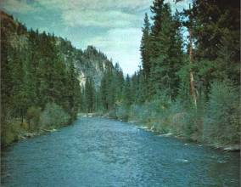
C. n = 0.057  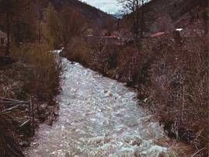 | D. n = 0.073  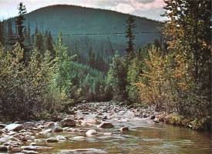
Photo 6-7 Channels have different roughness values. Images taken from USGS Water Supply Paper 1849, a compendium of channel roughness values with photographs and cross sections of channels in which the values were measured. A. n = 0.026, Indian Fork below Atwood Dam, near
New Cumberland, Ohio. B. n = 0.036 West Fork Bitterroot River near
Conner, Montana. C. n = 0.057 Mission Creek near Cashmere, Washington. D. n = 0.073 Boundary Creek near Porthill, Idaho.

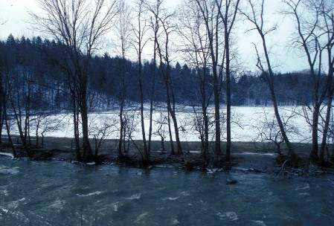
Photo 6-8. Bankfull flow on the Huntington River (basin area about 150 square km) during a mid-winter rain on snow event. The trees are on a natural levee. In the distance, flood flows have removed snow from an alluvial fan. Photo by P. Bierman. GEOMORPH0000000042.

NEED PHOTO
Photo 6-9. Photo of bars (and maybe various bar types)
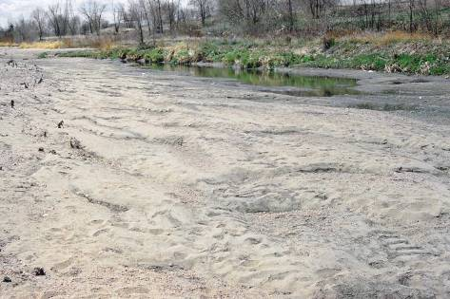
Photo 6-10. These bedforms are large sediment waves called dunes. Dunes form in subcritical flow with high sediment-transport rates. South Platte River, Colorado. Photo by D. Thompson. GEOMORPH0000001694.
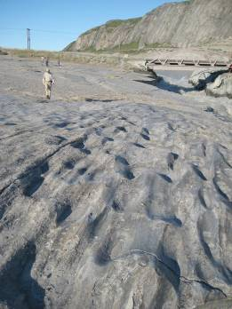
Photo 6-11. Fluted bedrock surface on a former bedrock bed now perched as a terrace above the Watson River near Kangerlussuaq, western Greenland. Photo by P. Bierman. GEOMORPH0000000244.

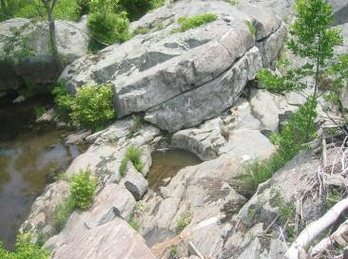
Photo 6-12. Joints in schist on the bed of the Potomac River provide weaknesses that allow tractive and lift forces developed during flood flows to pluck and move large pieces of rock. Note pot hole drilled on joint face. Photo by P. Bierman. GEOMORPH0000003989.
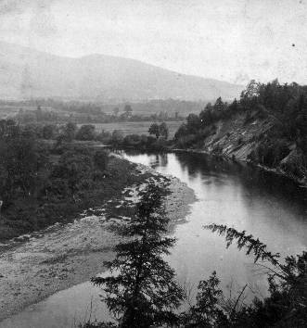
Photo 6-13. Paired point bar (left) and cutbank (right) on the Connecticut River in Brunswick, Vermont, C. 1870. Photo from Special Collections, Bailey/Howe Library, University of Vermont. GEOMORPH0000003990. . [BAD PHOTO CLUB]

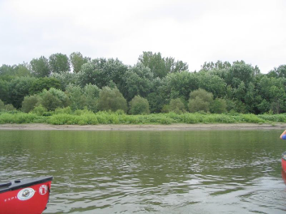
Photo 6-14. Point bar on the Winooski River with "layers" of vegetation indicating time since disturbance. Closest to the river, only annual grasses are present; farther back are shrubs, then small trees and at a distance, mature trees. Photo by P. Bierman. GEOMORPH0000000240. . [BAD PHOTO CLUB]

NEED PHOTO
Photo 6-15. want photo of alternate bars...
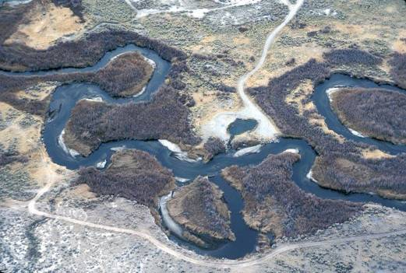
Photo 6-16. Aerial view of meanders (note cut-off) on floodplain of the Owens River, California. Photo by M. Miller. GEOMORPH0000001327.
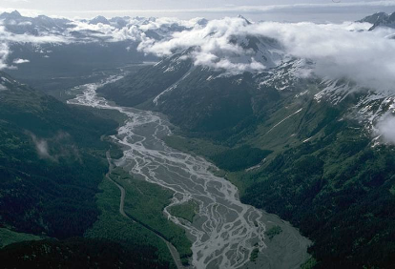
Photo 6-17. The braided Resurrection River in Alaska flows between steep valley walls. Photo by M. Miller. GEOMORPH0000001331.

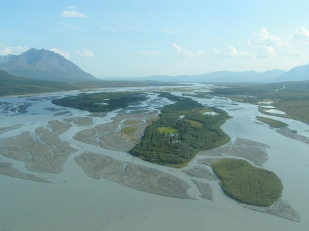
Photo 6-18. Anastomosing channel where some of the sandbars are stabilized by substantial vegetation growth. Alaska Range, Alaska. Photo by A. Matmon. GEOMORPH0000000704.

A 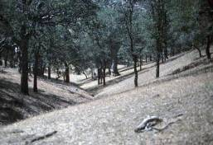 | B 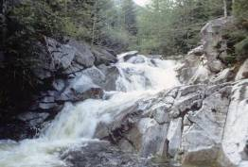
C 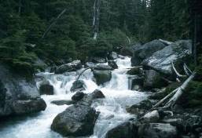 | D 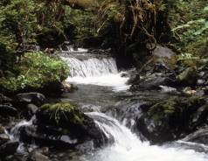
E 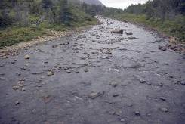 | F 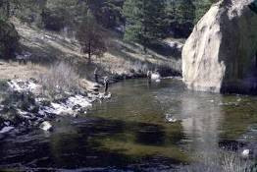
Photo 6-19. A. Colluvial reach near Oiler Peak, Sierra Nevada mountains, California. Photo by D. Montgomery. GEOMORPH0000000787. B. Bedrock channel reach on a tributary to the Tolt River, Washington. Photo by D. Montgomery. GEOMORPH945. C. Cascade reach. Washington. Photo by D. Montgomery. GEOMORPH762. D. Step pool channel, southeast Alaska. Photo by D. Montgomery. GEOMORPH897. E. Plane Bed, Gros Morne, Newfoundland, Canada. Photo by D. Thompson. GEOMORPH1768. F. Pool and riffle reach. South Platte River, Colorado. Photo by D. Thompson. GEOMORPH1718. [Bad photo club]
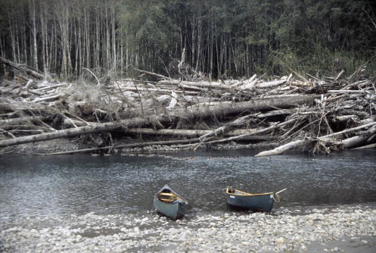
Photo 6-20 Log jam on the cutbank of a meander on the Queets River, Washington. Photo by D. Montgomery. GEOMORPH0000001043.

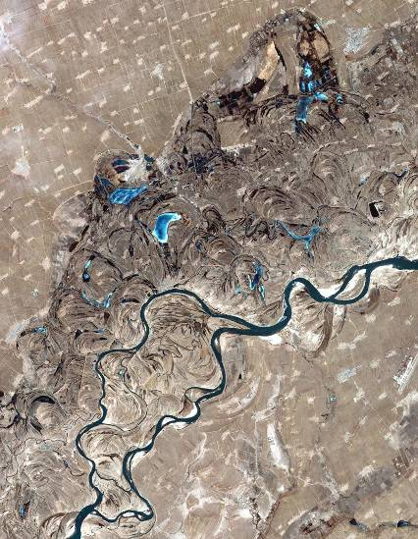
Photo 6-21. Satellite photo of the Songhua River, just west of Haerbin, northeast China. showing meanders, scroll-bars and oxbow lakes. Photo by NASA (ASTER_2002040). GEOMORPH0000003991.

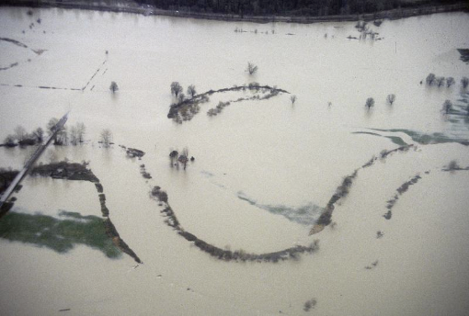
Photo 6-22. Natural levees define the channel of the Snohomish River in Washington during a 1996 flood. Photo by D. Montgomery. GEOMORPH0000001004.

Figure Captions
Figure 1. Discharge past a point.
Figure 2. Sediment sources to a channel.
- Figure 3. Diagram showing channel cross section parameters, subsurface velocity distribution in channels.
Figure 4. Bankfull flow and illustration of “at a station” hydraulic geometry relationships between discharge and channel depth, channel width, and water velocity.
Figure 5. Shear stress on the channel bed
Figure 8. Schematic illustration of bedload, suspension load, and saltation load in a stream.
Figure 6. Shields diagram & Hjulstrom diagrams which are useful for understanding how different grain sizes erode and are deposited in streams.
Figure 7. Bedload sediment transport rates increase once shear stress increased above a critical value that initiates transport.
- Figure 9. Bedrock erosion requires a critical threshold and just the right amount of sediment to provide tools for erosion but not to cover the channel bed.
Figure 10. Flow through meanders results in a predictable pattern of erosion and deposition as well as downstream translation of landforms over time.
Figure 11. Channels come in a variety of forms. These forms can be classified as single and multithread and sinuosity as well as meander wavelength can be quantified.
Figure 12. Channel patterns are determined by slope and discharge.
Figure 13. Large woody debris in channels influences the distribution of water and sediment and thus habitat.
Figure 14. Diagrammatic representation of floodplain formation processes and landforms.
- Figure 15. Channel response... Lane's balance and modern ven diagram

Worked problem; manning's N and Froude number.

