ESS 326 Geomorphology Name: ______________________
Lab 6: Glacial Erosion
Due: By end of day 3/14 to Sarah’s mailbox in JHN062 or in person

Introduction:
Alpine glacial erosion produces signature U-shaped valleys, while fluvial erosion tends to produce V-shaped valleys. Using a simple excel model, we will explore why glaciers tend to form U-shaped valleys and what processes are controlling this shape.
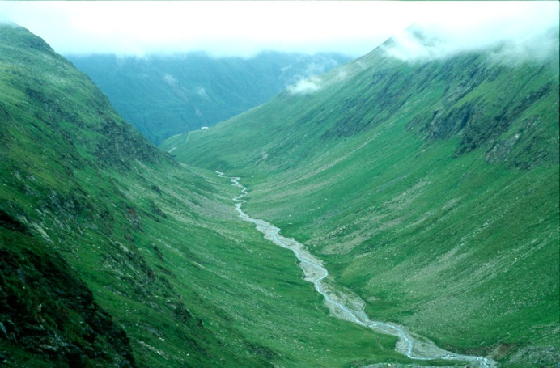
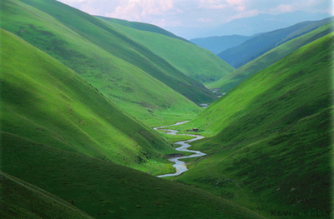
Left: V-shaped valley typical of fluvial erosion. Right: U-shaped valley characteristic of glacial erosion.
In this lab, we’ll investigate why glacially eroded valleys tend to be U-shaped in cross section. We’ll consider two erosion scenarios. For both scenarios, we’ll assume the glacier annually discharges 2.4 x 10⁴ m³ of sediment generated from an area of 12 x 10⁶ m². We will also assume that the ice volume remains constant through time.

Scenario 1: Assume the erosion rate E at the base of the glacier is equal at all points along the cross section.

Scenario 2: Assume the erosion rate along the base of the glacier is controlled by the basal velocity given by:
E=AU_{b}²
  - E is the erosion rate in meters per year,
  - A is a constant describing the bedrock’s resistance to erosion,
  - U_{b} is the basal ice velocity in meters per year. This is a function of the basal shear stress τ_{b}, where τ_{b}=ρgzsin(θ).

Question 1: Sketch a cross section of a V-shaped valley. Then for each erosion scenario, draw a series of profiles illustrating how you expect the valley profile will evolve with time under the two different scenarios. For the second scenario, keep in mind how you expect the basal velocity to vary along the cross section.
Scenario 1
Scenario 2

Modeling Glacial Erosion:
- The last page of the lab shows a V-shaped valley containing a glacier. The contours show ice velocity in m/yr. Divide the width of the glacier into 22 equal-width segments. Open the glacial erosion .xls file (on the lab website) and add the segment width values to the appropriate column.

- Estimate the mean ice depth and mean velocity for each segment and add the data to the spreadsheet. Calculate values of U_{b}² for each segment. (Hint: The glacier is symmetrical so you only need to measure half the segments!)

- Use the ice depth and segment width data to construct a graph showing the cross section of the glacier (the initial profile).

- Based on the information given on page 1, calculate the glacier’s average erosion rate (E_{av}), in meters per year. (Hint: If you know the sediment discharge i.e. the eroded material per year and the area, you can get erosion rate.

- Use the cross-section data and the erosion rate you calculated to fill in the data for Scenario 1 (column F). Construct a new cross section (Profile 1) depicting the glacier 100,000 years from now and add it to the graph of the initial profile.

- Use your original cross section data and the erosion rate you calculated in question 3 to construct Profile 2, a cross section of glacier 100,000 years from now assuming Scenario 2 (column G). Add Profile 2 to the plot along with the other profiles. Turn in the plot with the lab.
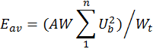
Hint: You know the average cross-section erosion rate, now determine how the erosion rate varies across the section. The erosion rate for each small segment is a function of A, which can be found using the following relationship:

Where is the average erosion rate, is the small segment width, is the total width, and is the number of small segments.
Question 2: Compare the 2 profiles. Which is more realistic? Why? What physical processes are accounted for by the more realistic model that are ignored by the other model?

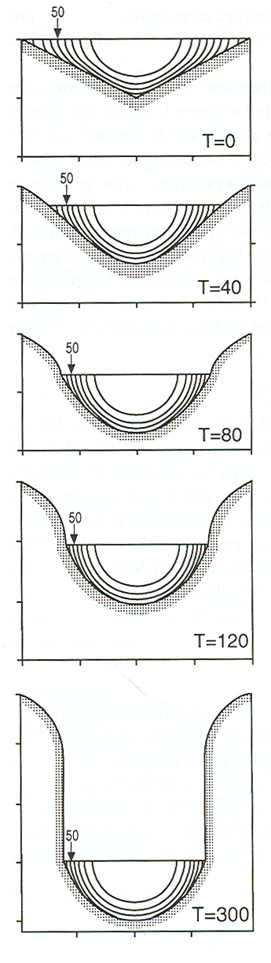
Model results simulating valley evolution with erosion scaled to the local basal velocity squared. From Harbor, 1992.

Investigate what happens to the U-shaped profile in Scenario 2 if we increase the erosion time (to 200, 300, 400 kyr). Turn in a plot of these erosion times. The figure to the right is from a similar model of glacial erosion, and you can see two key differences between their valley and our valley occur at 300 kyr. First, theirs is still U-shaped. Second, it has entrenched vertically.

Question 3: Is the W-shape that develops in our profile realistic? What specifically causes the model to do this? Describe in detail how you would improve the model to produce a more realistic profile.

Question 4: Describe several factors that in the real world might hinder a glacier from vertically entrenching like in the figure to the right at T=300 kyr.

Question 5: Given this model’s assumptions, how long would a valley have to be glaciated for it to be no longer identifiable as a fluvial valley?

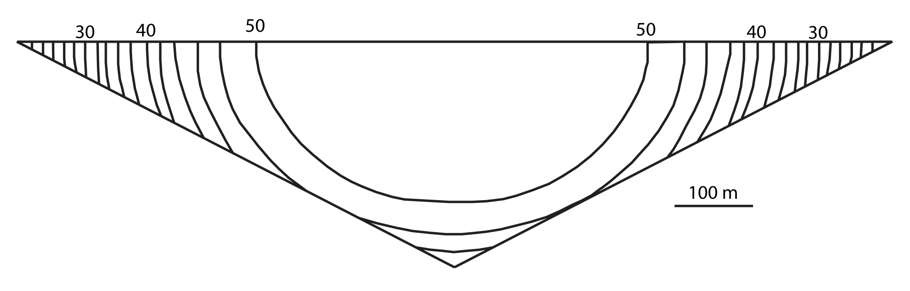
V-shaped valley containing a glacier. Contours show ice velocity in m/yr. Contour interval is 2 m/yr. Scale: 1 mm = 5 m.

