- Methods
  - Field Procedures
The Hood Canal Dissolved Oxygen Program, including the Skokomish Nation Department of Natural Resources, Mason County Health Department, Kitsap County Health District, Jefferson County Conservation District, and University of Washington, sampled 43 streams monthly from January 2005 to December 2006. The sampled streams include 77.7% of the land area in the Hood Canal watershed (the watershed area is 3143 km2, land area in the watershed is 2,671 km2, and 2,151 km2 of watershed area is sampled). Isco autosamplers were installed at gage locations on the Skokomish, Tahuya, and Union Rivers. During the onset of winter precipitation between November 2 and 17, 2006, streams were sampled sequentially 2- to 4-hourly (collecting approximately 96 samples per stream during the period). All bottles used for monthly and storm event sampling were 0.1 M HCl acid-washed in the lab. Monthly samples bottles were pre-rinsed with streamwater during collection.

Storm event and monthly samples were analyzed for dissolved organic C (DOC), total dissolved N (TDN), NO3-, NO2-, NH4+, SiO4, soluble reactive P (SRP), particulate N (PN), particulate organic C (POC), and total suspended solids (TSS).

  - Laboratory methods
Laboratory methods followed the project-specific Quality Assurance Project Plan (Roberts, Newton, Hannafious 2005). DOC and TDN were measured on a Shimadzu DOC analyzer after filtering through C-cleaned glass fiber filters (0.7 μm nominal pore diameter) into pre-cleaned glass vials. Dissolved nutrient samples (NO3, NO2, NH4, SiO4, and SRP) were cellulose acetate filtered (0.45 μm), sent to the UW Marine Chemistry Laboratory, and analyzed on an Alpkem RFA/2 autoanalyzer. Samples were filtered in the field or within 1 week of receipt. DON was calculated subtractively, based on measured TDN and DIN. When error associated with TDN and DIN produced negative DON concentrations, zeros were assigned.

Particulates were filtered onto C-cleaned glass fiber filters (0.7 μm nominal pore diameter), dried at 55° C, acid-fumigated for 24 hours, and dried at 55° C again. Particulate sample filters were packed in tin capsules and analyzed by gas chromatography mass spectrometry at the UC-Davis Stable Isotope Facility. Total suspended solids were glass-fiber filtered at UW Marine Chemistry lab, and concentration estimates were based on 2 pre- and 2 post-weights.
  - Compiling Ancillary Data (Streamflows and Watershed Characteristics)
    - Physical Characteristics

Mean watershed elevation and watershed mean slope were calculated based on a 10 m resolution digital elevation model (DEM). A filled 30 m DEM was used to create a stream network, delineate HCDOP-sampled watershed boundaries, and calculate watershed areas.

    - Streamflow estimates
All available gaged streamflow estimates for the Hood Canal area were compiled. This included any daily mean flows from 33 gaged streams between 1924 and December 31, 2006. Of the 43 monitored tributaries, 27 streams had no continuous streamflow data measurement during the 2005 – 2006 sampling. 16 of 43 monitored streams had some (or all) daily mean flow measurements available. Among these 16 streams, 14 are direct discharges to Hood Canal (i.e. 2 of the 16 gages are upstream of others). The 14 gages’ watershed areas sum to 68% of the total Hood Canal watershed area. During 2005 – 2006 monitoring all large Olympic Mountain rivers were gaged, and the ungaged area, a total 882 km2 (32%) of the watershed’s land area, was entirely in the Kitsap/Lowland region. The ungaged areas are small shoreline catchments and small to medium size tributaries. 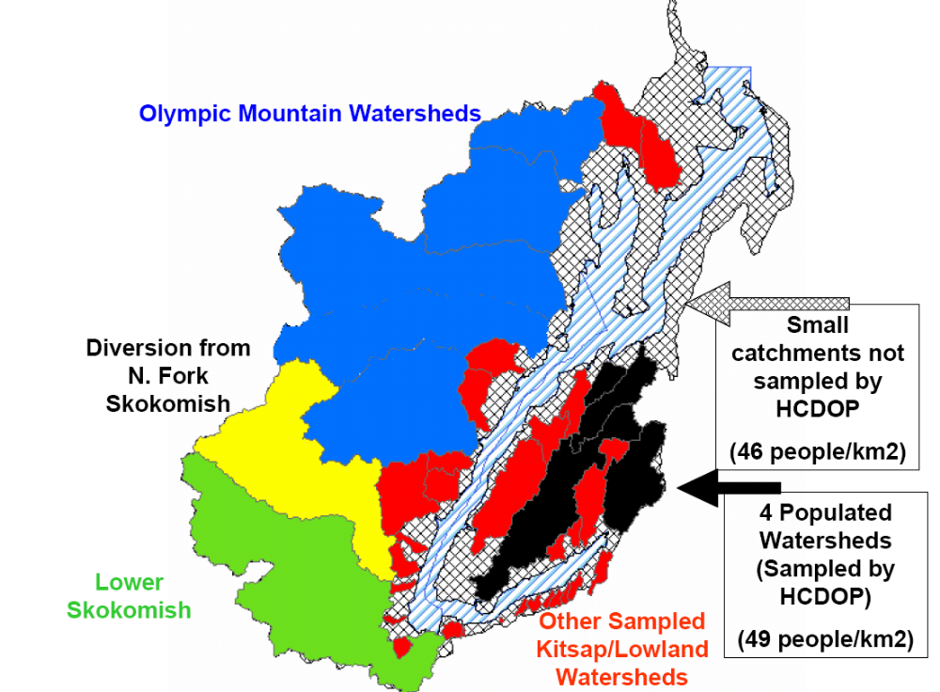
Streamflow estimates for ungaged watersheds, were needed to calculate loading rates and flow-weighted concentrations. The hydrologic record extrapolation needed to: 1) produce accurate seasonal streamflow patterns for each gaged stream with missing data (so that flow-weighted mean concentrations would be realistic), 2) provide flow estimates for catchments with no gage records at all, and 3) not significantly over/under estimate the total monthly streamflow (and constituent loading rates) from ungaged catchments.

A specific yield method was adopted, similar to that used in a study of N loading from small ungaged catchments in coastal Oregon (citation). For each day in the hydrologic record, gaged daily mean flows were drainage area normalized. Gaged and ungaged streams were classified by hydro-climatic region, as 1) Kitsap/Lowland, 2) Olympic Mountain (including the North Fork Skokomish gage at Staircase and South Fork Skokomish River gages, but not the lower Skokomish), or 3) Gages strongly affected by dams (Skokomish River at Hwy 101, North Fork Skokomish near Potlatch, North Fork Skokomish below Lower Cushman Dam, and Cushman dam power generation flows). For each day, the arithmetic mean of the daily specific yields in each region was applied to ungaged watersheds in each class:
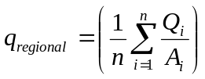,
with i=1 to n streams in a given region with flow data available for a particular day. Arithmetic means were used so that small gaged watersheds’ specific yields would have the same weight as large watersheds’ rates. This was important because the effort was aimed at estimating flows from, for the most part, small catchments sampled by HCDOP and small catchments not sampled. For water years 1982 to 1995, there were no October to April Kitsap/Lowland gage data (so the Kitsap/Lowland regional daily specific yield was undefined). There were Skokomish/Olympic Mountain gages in operation during this period. The Kitsap/Lowland daily specific yield during this period was estimated by using Olympic Mountain specific yields and monthly correction factors. The corrections factors were:
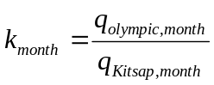,
where q_{Olympic,month} and q_{Kitsap,month} are long-term (1947 - 2006) monthly mean regional specific yields. For 1982 to 1995, when wet season gage data were not available for Kitsap/Lowland watersheds, the regional specific yield were estimated as:
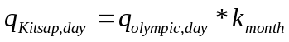
After applying the streamflow extension method to sampled and unsampled catchments at a daily time step, monthly mean flows were calculated and combined with monthly grab sample concentrations to calculate loading rates and flow-weighted concentrations.

During the 2005 - 06 sampling period ~25% of the Kitsap/Lowland watershed area was gaged, including south Kitsap (Union and Mission), North Kitsap (Big Beef and Seabeck), Dabob Bay/NW (Thorndyke and Tarboo), westside (Fulton, Johns, and JimmyComeLately Creek). For this period, the extension method accounts for the differences in precipitation among Kitsap/Lowland watersheds. Statistics for Kitsap/Lowland streams from this method for other time periods are likely biased by the lack of gage data for westside streams (Fulton Creek, in particular), south of the strong rain shadow effects.
    - Soils
All USDA – NRCS Soil Survey Geographic (SSURGO) data for the Hood Canal watershed were accessed (citation). This included digitized versions of the Mason County (cite), Kitsap County (cite), and Jefferson County (cite) soil surveys, as well as the Olympic National Forest Soil Survey (cite). SSURGO data for the 4 subregions were digital maps in vector (polygon) shapefile format, with polygons identified by unique map unit names and soil type codes. Typical soil chemical and physical characteristics and taxonomic information for each soil type code were available via the NRCS – National Soil Information System. Using this relational database, soil physical, chemical, and taxonomic attributes were joined to map polygons.

The merged soil map covered all of the Kitsap/Lowland portion of Hood Canal and the lower portion of the Olympic Mountains. The soils map covered 18%, 50%, 79%, 36% and 40% of North Fork Skokomish, Lake Kokanee, Skokomish, Dosewallips, and Duckabush watersheds, respectively. No effort was made to extrapolate soils map data into unmapped areas. The other 38 HCDOP-sampled watersheds had greater than 97% coverage. The merged soil map with all joined attributes was intersected with a shapefile of the 43 HCDOP-sampled watershed polygons. The resulting database file was summarized in a 43 rows (watersheds) by 14 columns (Appendix ?) soil matrix.

Of the final soil matrix, 5 columns were watershed mean intensive soil parameters (grams orgranic matter/m2, equivalents cation exchange capacity/ m2, %clay, subsurface (36 – 60 inches) bulk density, and soil available water capacity (inches AWC in surface 60 inches of soil)). Nine of the soil matrix columns were percentages of watershed area in 9 soil genetic classes. The soil classes were 1) andic soils /andisols (volcanic ash infuenced soils), 2) wetland mineral soils, 3) indurated soils (derived from glacial till), 4) Weakly developed non-glacial till soils (entisols and inceptisols not indurated), 5) histosols and histic soils (organic soils), 6) riverwash/water, 7) rock outcrops, 8) spodosols (generally sandy soils illuviating organic matter and sesquioxides from surface into defined subsurface horizons), and 9) hydric soils (mineral and organic wetland soils).

    - Land Cover
Lauren McGeoch created a land cover classification system for the Hood Canal watershed, classifying 30 m pixels into 14 land cover/land use classes based on a July 30, 2000 Landsat-Thematic Mapper image and supervised training (HCDOP website). In the classification system, the Puget Sound Regional Synthesis Model (PRISM) 2002 land use / land cover (LULC) map was used to mask urban areas and subalpine forests snow-cover areas (HCDOP website). Each sampled watershed’s land cover percentages were summarized in a 43 rows (watersheds) by 14 columns (land cover type) matrix.
    - Population Density
Population estimates for each watershed were developed by Lauren McGeoch. These were created by disaggregating 2000 US Census blocks and distributing the block’s population based on 30 m pixels’ classification in the PRISM 2002 LULC map and their deviations from the block’s mean normalized difference vegetation index (NDVI) (Cite HCDOP/Lauren).
  - Summary Statistics and Constituent Loading Rates

    - Filling in missing data
The monthly streamwater chemistry dataset included 43 streams, 24 months of data, and 11 constituents (DOC, TDN, NH4, NO3, NO2, PO4, SIO4, TSS, DON, PN, and POC). There were several data gaps because of sampling site access, and adding new sites to the sampled streams list. For each dissolved constituent, 55 – 82 % of the 1,075 possible observations existed. A correlation – based model was used to fill in missing concentration data in the monthly streamwater chemistry dataset. For each of the 43 monitored streams and each constituent, linear regressions against up to 5 correlated streams were used to estimate probable concentrations for each stream and each month with missing data. In cases where there were few correlates with a missing data stream (e.g. when a group of correlated streams was not sampled in a given month), missing months were assigned their measured concentrations from the same calendar month of another year. The correlation-based filled datasets were used for calculating flow-weighted concentrations, loading rates, and statistics. C:N ratios in dissolved and particulate fractions were calculated based on original (not filled) dataset.
    - Loading Rates

Monthly freshwater dissolved nutrient loads to Hood Canal were estimated by multiplying monthly mean streamflows and monthly grab sample concentrations. This accounted for loads from the 39 of 43 HCDOP sample locations that are direct discharges to Hood Canal (i.e. not upstream of other sample locations).

The monthly arithmetic mean of concentrations measured in 4 populated Kitsap watersheds (Big Beef (83.1 people/km2), Seabeck (61.4 people/km2), Tahuya (19.5 people/km2), and Union (33.3 people/km2)) was used as a monthly estimated concentration for the unsampled catchments in the Hood Canal watershed. The mean of these 4 watersheds’ population densities is 49 people/km2. The unsampled catchments in the Hood Canal watershed have a population density of 45.3 people/km2. The unsampled area (618 km2) was treated in aggregate with 1 concentration and monthly flow rate, rather than as individual watersheds. Its daily mean flows were estimated as the product of its area and the daily mean specific yield from Kitsap/Lowland gages. This formulation was intended to include all watershed constituent loading (surface and subsurface) from the small, populated catchments of the unsampled area. It is based on the assumption that, in the streams used in calculating regional daily specific yields, all (or very nearly all) water flux from gaged catchments is measured surface water.
  - Watershed Characteristics Effect on Nutrient Concentrations
Watershed characteristics for the sampled watersheds, including mean elevation, mean slope, watershed area, mean 2005 – 2006 discharge, population density, land cover percentages (14 columns), and soil characteristics (14 columns) were concatenated in a 43 rows by 33 columns predictor dataset. Since the number of predictor columns was high and many predictors were inter-correlated, it was necessary to reduce the dimensionality of the dataset.

Principal components analysis was used as a dimension reduction method. It finds orthogonal axes that maximize the amount of total variance explained in the fewest axes. The PCA algorithm does not standardize variances. Within the soils matrix, columns had different units, magnitudes, and variances, so the matrices were standardized by their column standard deviations to homogenize variance. This is the same as running the PCA algorithm on a correlation matrix. Soils matrix columns appearing log-normally distributed (having elements with z-scores >3), were log transformed prior to homogenization of variance and PCA. In the land cover matrix, columns had identical units (percent watershed area) and no z-scores >3, so it was not necessary to standardize variances. The land PCA was thus run on a covariance instead of a correlation matrix. Only statistically significant PCA’s were retained for multiple regression.

Three significant soil principle components, 2 significant land cover principal components, mean annual streamflow, watershed mean slope, watershed area, population density, and elevation were used as a reduced predictor matrix in multiple regression models to predict each constituent. Mean annual flow, watershed area, and population density had elements with z-scores >3 and were log transformed before multiple regression.

An all subsets multiple regression model was used. This method creates many models by regressing all possible combinations of factors against the response variable. For subsets of length r and n possible factors to include in the regression model, the number of total number of combinations, including all subsets of lengths from 1 to n is:
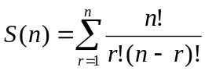
Since there were 11 columns in the predictor matrix, there were 2047 possible subsets of factors, including 11 1-factor models, 55 2-factor models, 165 3-factor models, 330 4-factor models, 462 5-factor models, as well as the 6- to 11- factor models. Among these, the only models retained for comparison were those where all factors’ p values were less than 0.05. There were no 6- to 11-factor models where all terms were significant. The most probable (best) model was selected from all significant models using the Akaike information criterion (AIC),
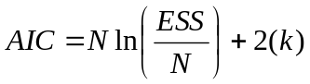,
where N is the number of observations (43 in all cases), ESS is the sum of squared errors of the estimate, and k is the number of parameters (including variables and intercept) (citations). The AIC minimization is aimed at finding a regression that explains variability of the response using a minimal number of parameters. The ΔAIC,
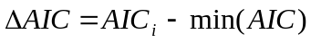,
was used for comparison, to estimate the likelihood there were probable models other than the minimum AIC model. ΔAICi values >10 indicate a particular model is much less probable than the minimum AIC model. Values < 2 indicate a model is very nearly as probable as the minimum AIC model. The Akaike weight, often expressed as a percentage, is the untransform of each ΔAICi divided by the sum of untransformed ΔAIC’s:
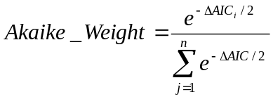,

- Results
  - Seasonal and Regional Patterns in Loads and Concentrations
    - Dissolved Nitrogen
The whole watershed 2-year flow weighted average TDN concentration was 152 ug/L (Reference to summary table below). 2-year flow-weighted average TDN concentrations were 283 μg/L in the sampled Kitsap/Lowland streams, 108 μg/L in Olympic Mountain watersheds, 106 μg/L in Skokomish River, and 72 μg/L in the diversion from North Fork of Skokomish. The 2-year flow-weighted mean concentration of the 4 most populated streams, the concentration applied to the unsampled area, was 452 ug/L. The 2005 annual TDN load was 699.7 MT, and it was 698.2 MT in 2006, even though flow was 29% higher in 2006 than 2005 (Reference to 2nd table below – comparison of loads between years).

Scaling TDN loads by drainage area, the catchment above the diversion from the North Fork of the Skokomish, and the other Olympic Mountains had similar rates (1.7 and 1.9 kg/ha/yr, respectively), and the mainstem Skokomish watershed had the highest rate (4.2 kg/ha/yr). The estimated loading rate of the Kitsap/Lowland unsampled area was 3.2 kg/ha/yr, which was higher than that of the sampled area (2.1 kg/ha/yr).
Summary Table. Regional flow-weighted mean concentrations, annual loading rates, and area - normalized loading rates based on 2005 - 06 HCDOP monthly grab samples.
Flow-Weighted Mean Concentrations (ug/L)
 | NO3 | NH4 | NO2 | DIN | DON | TDN | PN | TON | TN
N Fork Skokomish Diversion | 22 | 10.0 | 0.4 | 33 | 38 | 72 | 36 | 75 | 108
Skokomish River | 71 | 9.5 | 2.9 | 83 | 22 | 106 | 81 | 103 | 186
Sampled Kitsap/Lowland Watersheds | 198 | 12.7 | 0.9 | 212 | 72 | 283 | 37 | 108 | 319
Unsampled Kitsap/Lowland Watersheds | 325 | 12.7 | 1.0 | 339 | 114 | 452 | 43 | 157 | 495
Other Olympic Mountain Rivers | 61 | 7.6 | 0.4 | 69 | 38 | 108 | 34 | 72 | 142
Flow - Weighted Mean Concentration (ug/L N): All Hood Canal tributaries | 97 | 9.5 | 1.2 | 108 | 44 | 152 | 49 | 93 | 201
Loads (Metric Tonnes/Year)
 | NO3 | NH4 | NO2 | DIN | DON | TDN | PN | TON | TN
N Fork Skokomish Diversion | 14 | 6.2 | 0.23 | 20 | 24 | 44 | 22 | 46 | 67
Skokomish River | 95 | 12.8 | 3.95 | 111 | 30 | 141 | 109 | 139 | 250
Sampled Kitsap/Lowland Watersheds | 86 | 5.5 | 0.37 | 92 | 31 | 122 | 16 | 47 | 138
Unsampled Kitsap/Lowland Watersheds | 144 | 5.6 | 0.42 | 150 | 50 | 199 | 19 | 69 | 218
Other Olympic Mountain Rivers | 109 | 13.5 | 0.63 | 124 | 68 | 192 | 60 | 128 | 252
Total Annual Load | 447 | 44 | 5.6 | 496 | 202 | 699 | 226 | 429 | 925
Loading Rates (Kg/Year/Hectare)
 | NO3 | NH4 | NO2 | DIN | DON | TDN | PN | TON | TN
N Fork Skokomish Diversion | 0.5 | 0.24 | 0.01 | 0.8 | 0.9 | 1.7 | 0.9 | 1.8 | 2.6
Skokomish River | 2.8 | 0.38 | 0.12 | 3.3 | 0.9 | 4.2 | 3.2 | 4.1 | 7.5
Sampled Kitsap/Lowland Watersheds | 1.5 | 0.10 | 0.01 | 1.6 | 0.5 | 2.1 | 0.3 | 0.8 | 2.4
Unsampled Kitsap/Lowland Watersheds | 2.3 | 0.09 | 0.01 | 2.4 | 0.8 | 3.2 | 0.3 | 1.1 | 3.5
Other Olympic Mountain Rivers | 1.1 | 0.14 | 0.01 | 1.3 | 0.7 | 1.9 | 0.6 | 1.3 | 2.6
Whole Watershed Loading Rates | 1.62 | 0.16 | 0.02 | 1.79 | 0.73 | 2.52 | 0.82 | 1.5 | 3.3

Most of the TDN load was in the form of NO3-, particularly in wet months. In November to February NO3 was 65 to 76% of monthly TDN loads, in June to August both years, NO3 was 45 to 62% of TDN load. NO3 was 67 to 93% of DIN, with a flow-weighted mean of 89%. In 17 of 24 months of monitoring, NO3 was >80% of DIN. NO3 was less than 80% of DIN in 3 months in 2005 (July, September, and October), and in 4 months in 2006 (June, August, September, and October). Average annual NO3- loads were 447 metric tonnes, including 94.8 (21.1%) from the Skokomish River, 13.8 (3.09%) from diversion from North Fork of Skokomish, 85.7 (19.2%) from the sampled Kitsap/Lowland region, 143.5 (32.1%) from the unsampled Kitsap/Lowland region, and 109.5 (24.5%) from other Olympic Mountain rivers.

Monthly mean regional TDN and NO3 concentrations were generally weakly positively correlated with monthly mean streamflow (Cite Table below).
 | TDN correlation (r) with monthly mean streamflow | NO3 correlation (r) with monthly mean streamflow
Diversion from N Fork Skokomish | 0.41 (p = 0.05) | 0.48 (p = 0.02)
Skokomish River | 0.46 (p = 0.03) | 0.41 (p = 0.04)
Sampled Kitsap/Lowland Watersheds | 0.52 (p = 0.01) | 0.54 (p = 0.01)
Unsampled Kitsap/Lowland Watersheds | 0.32 (p = 0.12) | 0.56 (p = 0.004)
Other Olympic Mountain Rivers | 0.48 (p = 0.02) | 0.69 (p = 0.0002)

Table X. Comparison of annual loads during a dry (2005) and wet (2006) calendar year.
 | 2005 - 2006 Average | 2005 | 2006 | Difference (2006 - 2005)  (difference as percentage of 2005 - 06 average)
Total Freshwater Discharge | 5150 | 4501 | 5799 | 1298 CFS (25.2%)
Mt Crag Snotel Peak Snow Water Equivalent (inches) | 28.6 | 18.4 | 38.7 | 20.3 Inches SWE (71.1%)
Loads (Metric Tonnes/Year) | 2005 - 2006 Average | 2005 | 2006 | Difference (2006 - 2005)  (difference as percentage of 2005 - 06 average)
NO3 | 447 | 433 | 461 | 28.5 MT (6.4%)
NH4 | 43.5 | 47.6 | 39.5 | -8.2 MT (-18.8%)
NO2 | 5.6 | 3.4 | 7.8 | 4.4 MT (78%)
DIN | 496 | 484 | 509 | 24.7 MT (5%)
DON | 202 | 216 | 189 | -26.8 MT (-13.2%)
TDN | 699.0 | 699.7 | 698.2 | -1.5 MT (-0.2%)
PN | 226 | 162 | 291 | 129 MT (57.1%)
TON | 429 | 377 | 480 | 103 MT (23.9%)
TN | 925 | 861 | 989 | 128 MT (13.8%)
DOC | 4681 | 4202.2 | 5160.3 | 958 MT (20.5%)
POC | 2299 | 1677 | 2920 | 1243 MT (54.1%)
TOC | 6980 | 5880 | 8080 | 2201 MT (31.5%)
SRP | 33.2 | 29.2 | 37.2 | 8.03 MT (24.2%)
SIO4 | 22052 | 19652 | 24451 | 4799 MT (21.8%)

Dissolved organic nitrogen was also an important component of TDN. In warm/dry months, it was generally greater than 35% of TDN. In cool/wet months DON was generally 18 to 35% of TDN. One exception was March 2006, where DON load was 62.5% of TDN load. Based on whole watershed flow-weighted average monthly concentrations, monthly TDN was significantly correlated with NO3 and DON (r = 0.91 and 0.52, respectively). DON and NO3 were not correlated in time (r = 0.12, p = 0.40), but 2-year flow-weighted mean concentrations were weakly correlated from stream to stream (r = 0.33, p = .03). Average annual DON loads were 202 metric tonnes, including 23.6 (11.7%) from the diversion from North Fork Skokomish, 29.9 (14.8%) from Skokomish river, 30.9 (15.3%) from sampled streams in the Kitsap/Lowland region, 50.1 (24.8%) from the unsampled Kitsap/Lowland region, and 67.7 (33.5%) from Olympic Mountain watersheds.

Concentrations of NH4 were generally low and the load was a minor (6.23%) component of the TDN load. Among 43 streams’ 2-year flow-weighted average concentrations, the mean was 15.6 ug/L, and the median was 9.7 ug/L. The large standard deviation (34.5 ug/L), was attributable in part to Hill Creek, which had a much higher mean concentration (234 ug/L). Using whole watershed monthly flow weighted mean concentrations, NH4 was weakly and non-significantly correlated with TDN and NO3 (r = 0.32 and 0.33, p = 0.12 and 0.10, respectively). Based on whole watershed monthly flow-weighted mean concentrations, NH4 was at most 17.9% of the monthly TDN load. In 15 of 24 months, generally drier/warmer months, NH4 was less than 10% of the TDN load. Average annual NH4 loads were 6.2, 12.8, 5.5, 5.6, and 13.5 metric tonnes for the diversion from North Fork Skokomish, Skokomish River, sampled Kitsap/Lowland watersheds, unsampled Kitsap/Lowland watersheds, and Olympic Mountain watersheds, respectively.

Nitrite was the smallest measured fraction of TDN; it was 0.8% of the TDN load. From month to month, NO2 was weakly, though not statistically significantly, correlated with DOC and SRP (r = 0.40 and 0.38, p = 0.08 and 0.08, respectively). It was not correlated with any other N species. NO2 was generally nearly 1% of the monthly TDN load, but in September and November 2006, it was 3.67 and 4.45% of TDN, respectively. Most of the measured NO2 load was from the Skokomish River, particularly in September and November 2006. Average annual loads were 0.2, 3.9, 0.4, 0.4, and 0.6 metric tonnes for the diversion from North Fork Skokomish, Skokomish River, sampled Kitsap/Lowland watersheds, unsampled Kitsap/Lowland watersheds, and Olympic Mountain watersheds, respectively.

    - Particulate N

Averaging 2005 and 2006, the annual PN load to Hood Canal was 24.5% of the TN load (226 out of 925 metric tonnes). On a monthly load basis, PN was 5 to 50% of TN and generally highest in summer months. Total organic N (PN + DON) was 46.3% of the TN load to Hood Canal. In the Olympic Mountain streams (n=5), TON load was 55.4% of TN, in the Skokomish River it was 50.8% of TN; in the sampled Kitsap/Lowland streams (n = 35), TON was 33% of TN. Figure X shows Olympic Mountain streams’ N concentrations over 2 calendar years, with peaks in TON and TN associated with November/December rain and March to May snowmelt.
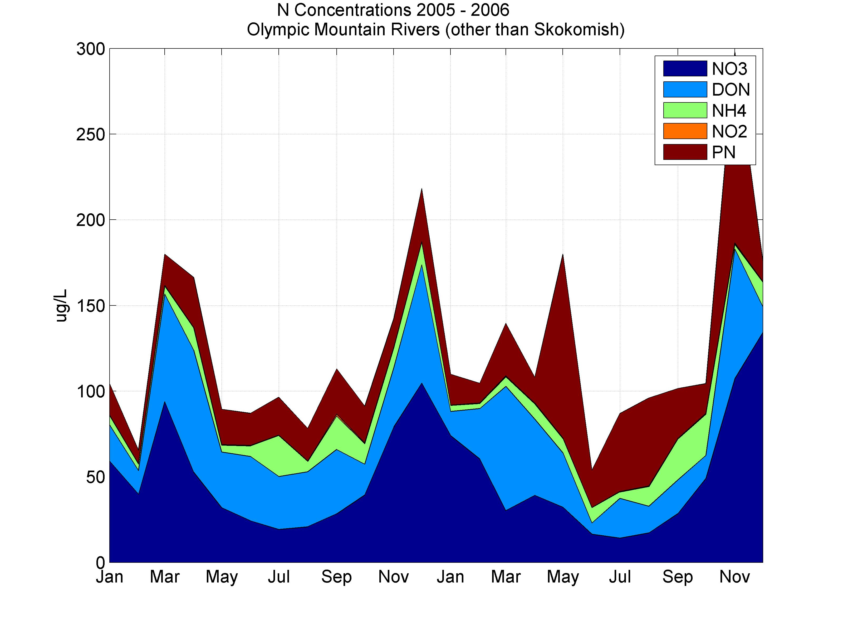
Figure X shows sampled Kitsap/Lowland streams N concentrations over 24 months, with a November/December peak in TN, and without the snowmelt signal of the Olympic Mountain streams. Note that the Kitsap/Lowland concentrations shown are averaged over 35 streams, while the Olympic Mountains figure shows averages of 5 streams.
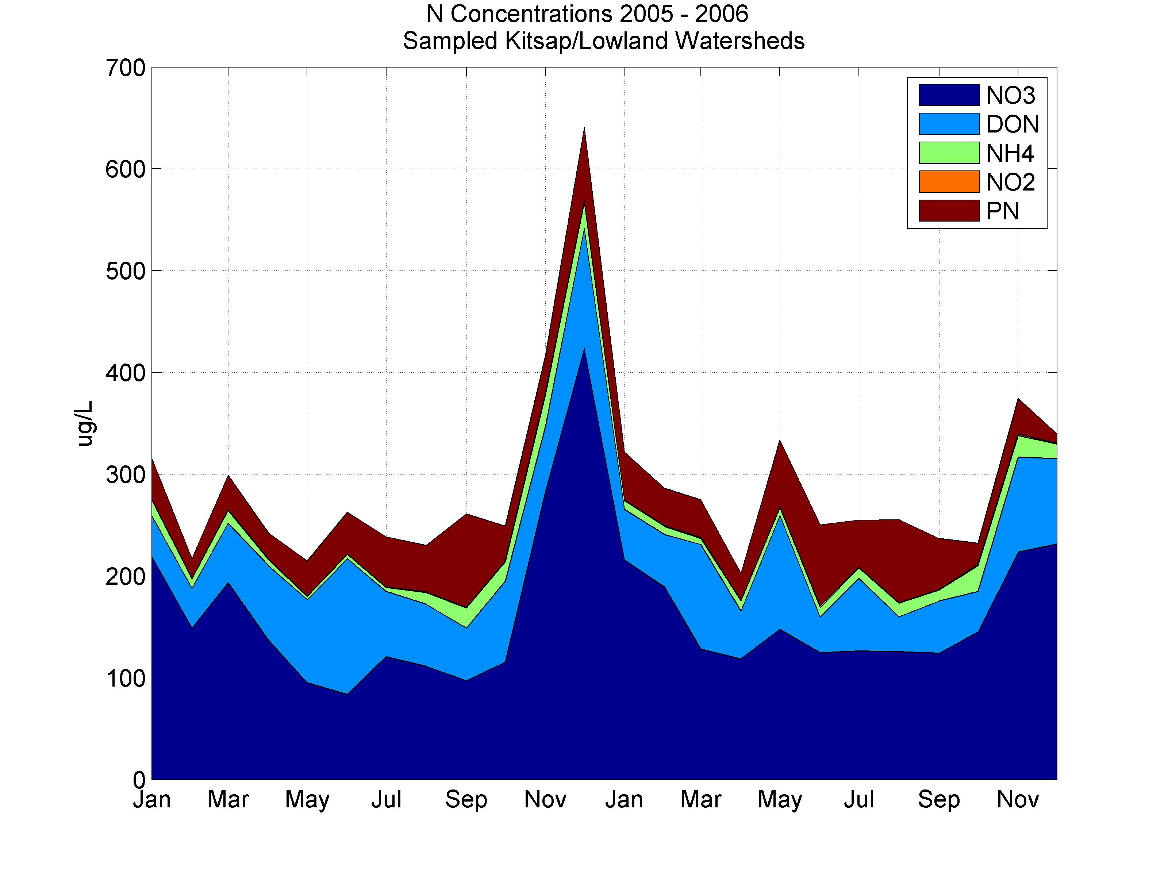

    - Dissolved Organic C

DOC concentrations were lowest in summer and concentrations in the 5 regions were generally weakly positively correlated with monthly mean streamflow (r = 0.31 in Skokomish River to r = 0.66 for unsampled Kitsap/Lowland streams). Average annual DOC load was 4,681 metric tonnes: 57.7% was from the Olympic Mountain watersheds, Skokomish River, and diversion from North Fork of Skokomish, and 40.3% was from sampled and unsampled Kitsap/Lowland watersheds. From month to month, Hood Canal watershed wide flow-weighted mean DOC concentrations were positively correlated with TDN and NO3 (r = 0.78 and 0.70, respectively, p < .00001), and less correlated with NO2 and DON (r = 0.40 and 0.44, p = 0.08 and 0.02, respectively). Comparing tributaries’ 2-year flow-weighted mean concentrations, DOC was positively correlated with TDN, NO3, and DON (0.77, 0.68, and 0.71, respectively, p < .00001).
Summary Table. Regional flow-weighted mean concentrations, annual loading rates, and area - normalized loading rates based on 2005 - 06 HCDOP monthly grab samples.
Flow-Weighted Mean Concentrations (ug/L)
 | DOC | POC | TOC | SRP | SIO4
N Fork Skokomish Diversion | 836 | 396 | 1232 | 0.7 | 2927
Skokomish River | 473 | 871 | 1344 | 15.5 | 5842
Sampled Kitsap/Lowland Watersheds | 2180 | 355 | 2535 | 9.4 | 6296
Unsampled Kitsap/Lowland Watersheds | 2352 | 388 | 2740 | 9.5 | 6457
Other Olympic Mountain Rivers | 869 | 310 | 1180 | 2.1 | 3842
Flow – Weighted Mean Concentration: All Hood Canal tributaries | 1016 | 496 | 1512 | 7.2 | 4783
Loads (Metric Tonnes/Year)
 | DOC | POC | TOC | SRP | SIO4
N Fork Skokomish Diversion | 514 | 244 | 758 | 0.43 | 1803
Skokomish River | 635 | 1176 | 1811 | 20.7 | 7838
Sampled Kitsap/Lowland Watersheds | 945 | 153 | 1098 | 4.05 | 2720
Unsampled Kitsap/Lowland Watersheds | 1038 | 171 | 1209 | 4.14 | 2845
Other Olympic Mountain Rivers | 1549 | 555 | 2104 | 3.81 | 6845
Total Annual Load | 4681 | 2299 | 6980 | 33.2 | 22050
Loading Rates (Kg/Year/Hectare)
 | DOC | POC | TOC | SRP | SIO4
N Fork Skokomish Diversion | 20.3 | 9.6 | 29.9 | 0.02 | 71.1
Skokomish River | 19.0 | 35.1 | 54.1 | 0.62 | 234.2
Sampled Kitsap/Lowland Watersheds | 16.4 | 2.7 | 19.0 | 0.07 | 47.1
Unsampled Kitsap/Lowland Watersheds | 16.8 | 2.8 | 19.6 | 0.07 | 46.1
Other Olympic Mountain Rivers | 15.7 | 5.6 | 21.4 | 0.04 | 69.5
Whole Watershed Loading Rates | 16.9 | 8.3 | 25.2 | 0.12 | 79.7

Linear regression, using all measured DOC and DON concentrations (n = 677), showed DOC and DON concentrations had a mass ratio of 12.3. However, this regression explained little variability (r2 = 0.42), and the intercept was large (718 ug/L C), perhaps because DON was calculated by subtraction and zeroed when negative. Looking at the distribution of DOC: DON mass concentration ratios (n=677) rather than a regression, the median DOC : DON mass ratio was 25.3 (Figure X (below)). On an average annual loading basis DOC : DON load ratios were similar to the median DOC:DON concentration mass ratio. DOC: DON load ratios were 21.7, 21.2, 30.5, 20.7, and 22.9 in the diversion from North Fork Skokomish, Skokomish River, sampled Kitsap/Lowland streams, unsampled Kitsap/Lowland streams, and other Olympic Mountain rivers, respectively.
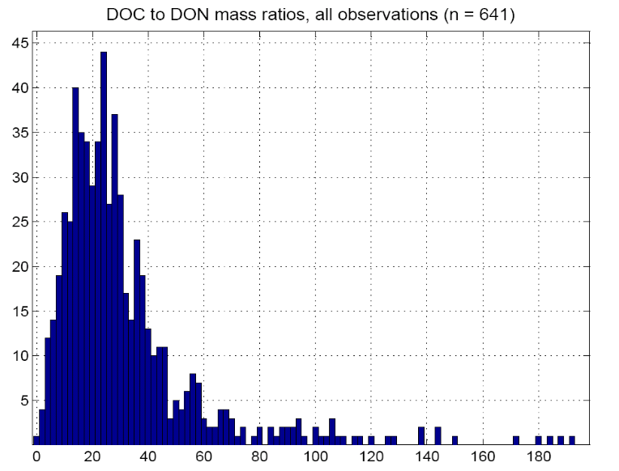
    - Particulate and Total Carbon

The 2-year flow-weighted mean POC and TOC concentrations for the whole watershed were 496 ug/L and 1,512 ug/L, corresponding to loads of 2,299 and 6,980 metric tonnes annually, respectively. Like the PN monthly grab samples, the POC data are highly variable from month to month unless averaged over several streams. Monthly and/or regional averages over 2 years show seasonal patterns more accurately until storm event POC data can be used to empirically predict daily concentrations (in progress). The flow-weighted monthly average concentrations from sampled Kitsap/Lowland streams show POC was never >40% of TOC (Figure X).
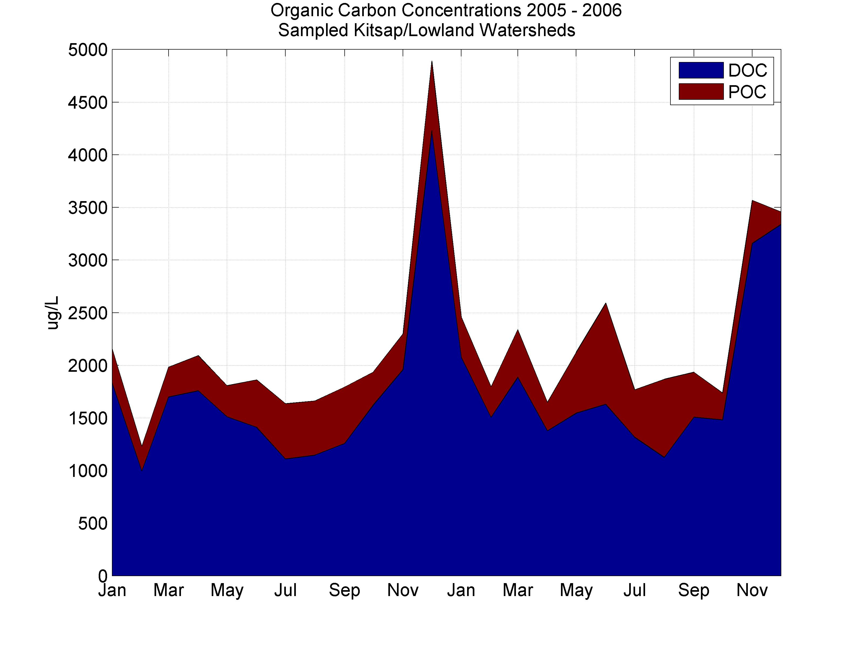
Olympic Mountain streams had POC >40% of TOC in 4 of 24 months of monitoring (Figure X). Winter 2005 – 2006 peaks in TOC occurred in December and during March to May snowmelt. In November 2006 (a month of record precipitation) and December, TOC concentrations were 2,217 and 2,945 ug/L, respectively, much greater than concentrations in earlier sampled wet months.
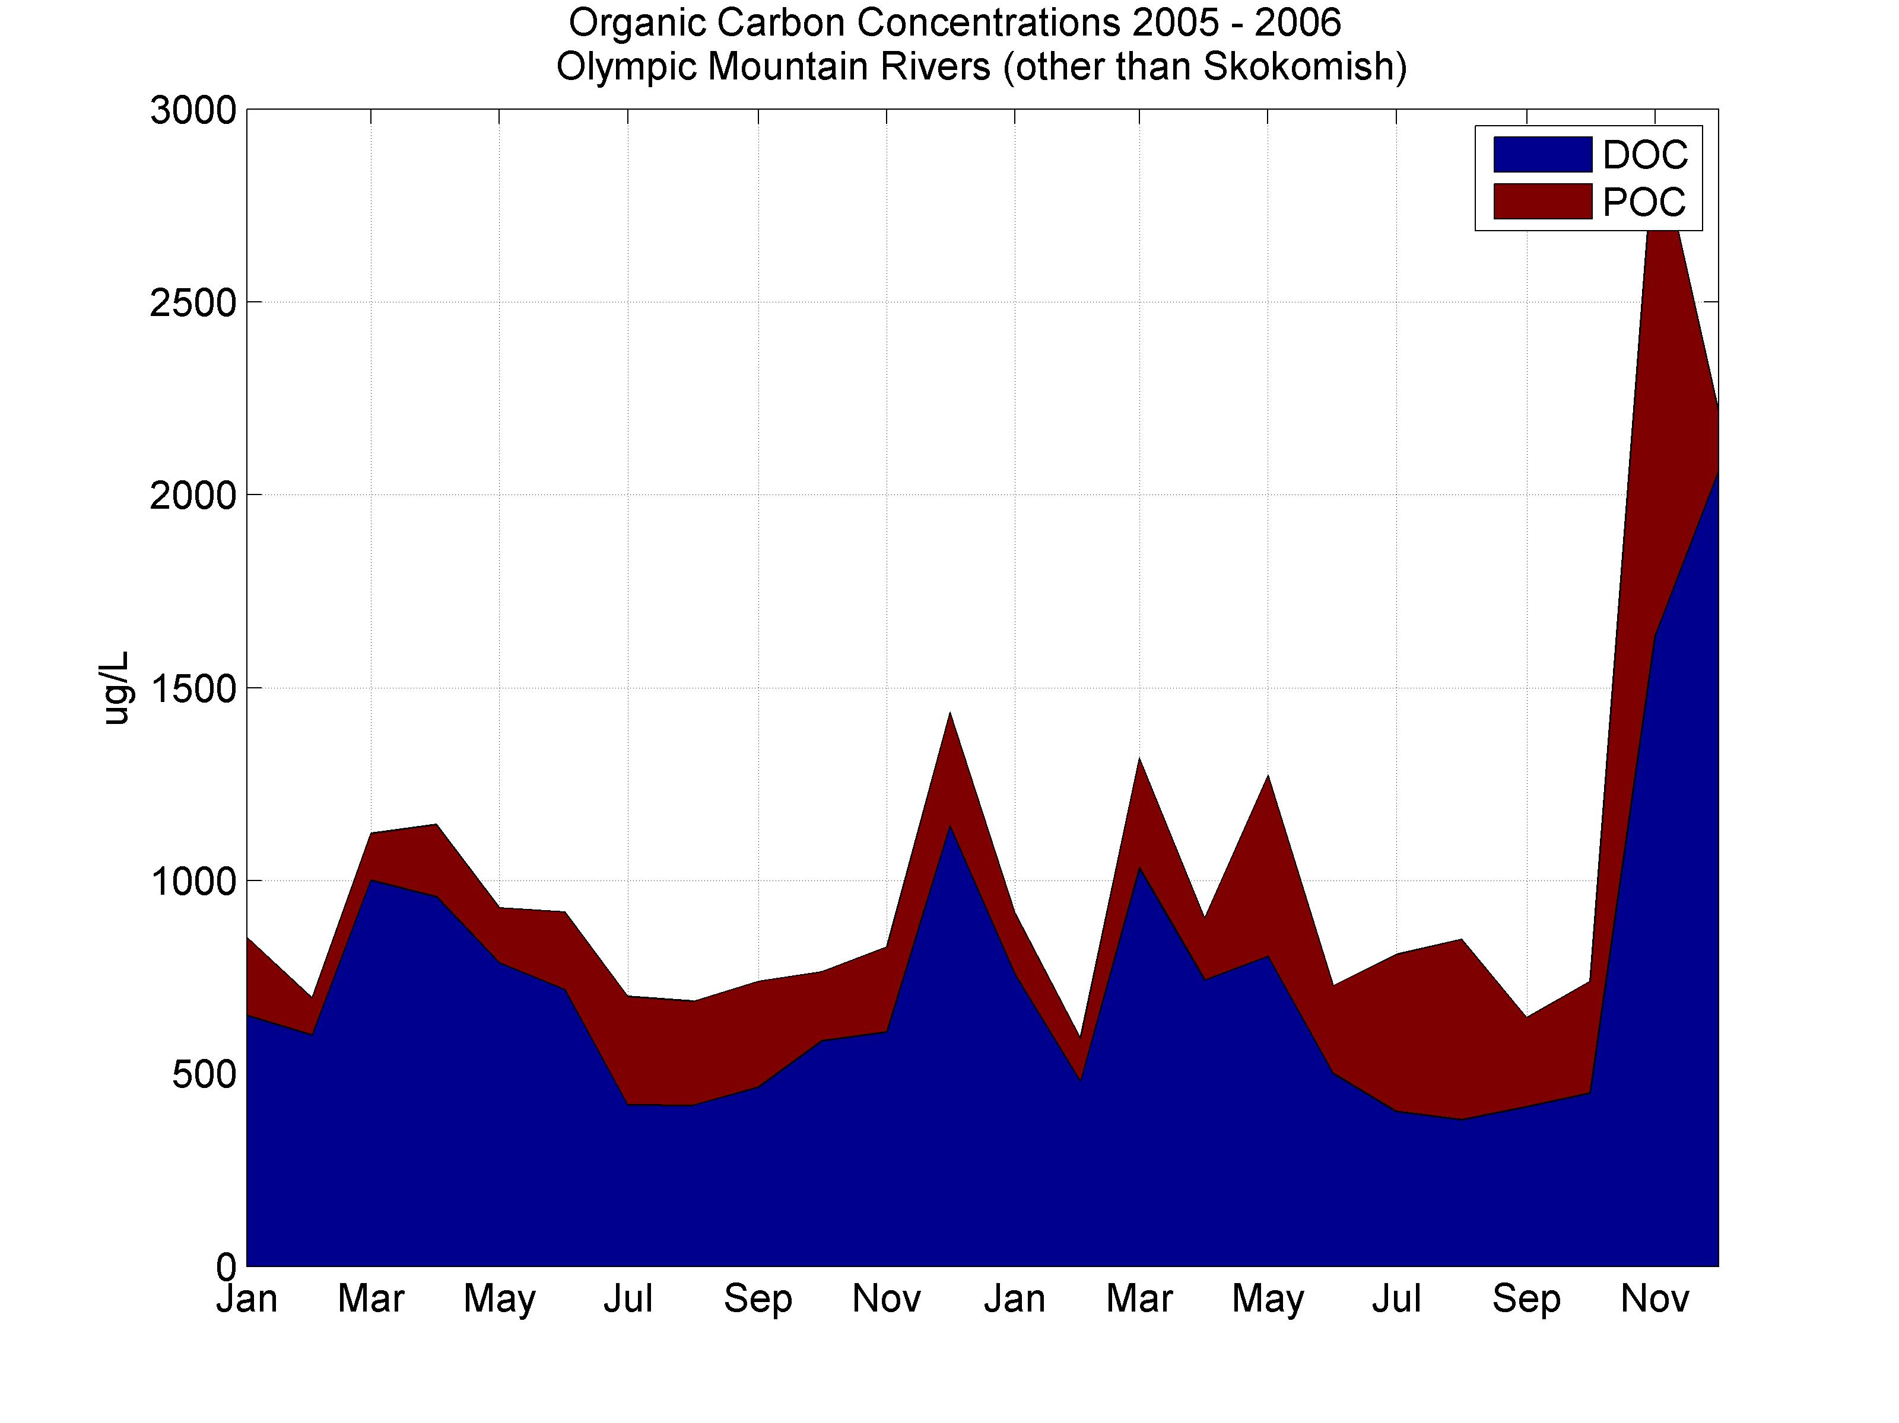
In December 2005 and November 2006, Skokomish POC was 75.6% and 80.4% of TOC, respectively. The median percentage was 35.9%. Figure X shows Skokomish POC and DOC concentrations. The large discontinuities in monthly Skokomish POC concentration indicate a need for empirical prediction of daily concentrations, averaging over several locations, and/or more frequent sampling.
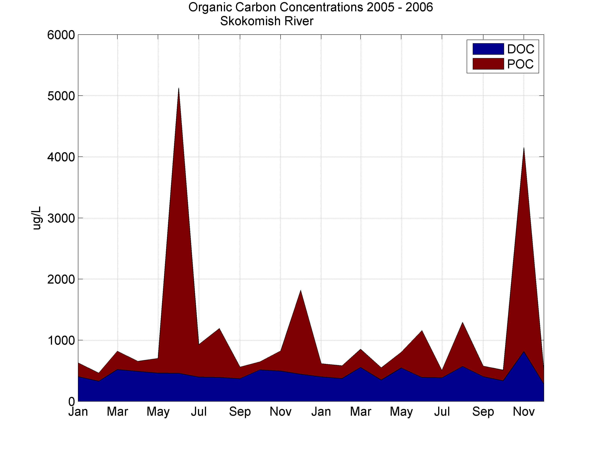
Particulate C:N (POC:PN) ratios by linear regression were 7.19 (6.86 – 7.53. The regression excluded PN and/or POC concentrations with z-scores greater than 3 (n = 597) and had an (R2 = 0.75). Again, the intercept was large (102 ug/L POC). Excluding samples with low PN concentrations (<20 ug/L) did not improve the regresson. The distribution of 597 POC: PN ratios has a mean of 10.2, median of 9.48, and standard deviation of 3.02 (Figure ).

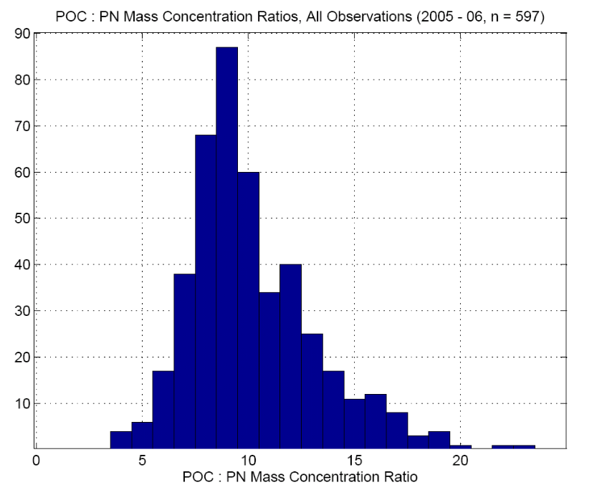
TOC: TON ratios by linear regression were 13.1 (11.7 - 14.4), and the intercept was high (512 ug/L) (R2 = 0.47, n = 421). The distribution of TOC : TON ratios had a mean of 21.5, median of 18.8, and standard deviation of 12.8 (Figure).
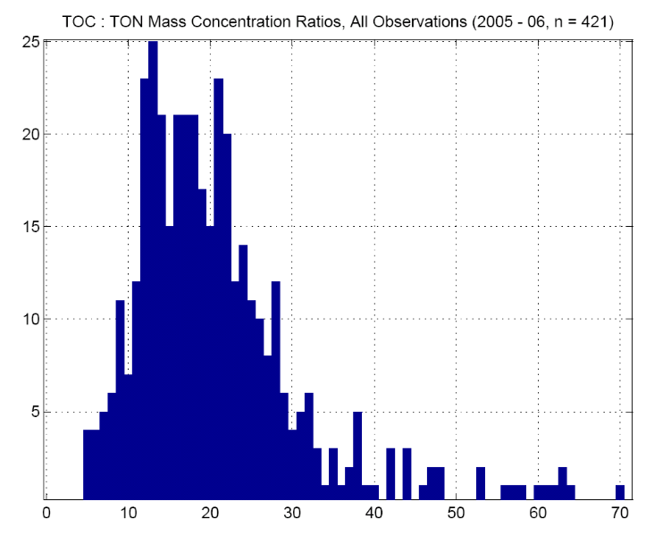

    - Silicate
Silicate concentrations were highest in Kitsap/Lowland watersheds; loading rates and area normalized loading rates were highest in the Skokomish and Olympic Mountain watersheds. Total SiO4 loads were 22,050 metric tonnes per year: 25% was from the Kitsap/Lowland region, and 75% came from the Skokomish watershed (including the diversion and mainstem) and other Olympic Mountain rivers. 2-year regional SiO4 flow-weighted concentrations were highest in Kitsap/Lowland streams. Area normalized loading rates show the inverse pattern, with highest rates in the Skokomish River, Olympic Mountains, and diversion from North Fork Skokomish and lowest rates in Kitsap/Lowland watersheds. Silicate concentrations were highest in summer, and seasonal differences were strongest in the Kitsap/Lowland region. From stream to stream, based on 2-year flow-weighted mean concentrations, SiO4 was correlated with SRP (r = 0.54), but not with DOC, or any N species.

    - Soluble Reactive Phosphorous

Soluble reactive P loads averaged 33.2 metric tonnes annually, with most (20.7 metric tonnes, 67.3%) coming from the Skokomish River. Kitsap/Lowland region average annual loads from sampled and unsampled regions totaled 8.19 metric tonnes (25%). Qualitatively, there were no seasonal patterns in SRP common among the regions. Kitsap concentrations averaged 9.5 ug/L and were highest in late summer. There were no strong seasonal patterns in Skokomish River SRP concentrations; they averaged 15.5 ug/L and were below 12 ug/L in July 2005, and September, October and December 2006.

  - Watershed Effects on Nutrient Concentrations

    - Principal Components Analysis

The land cover matrix was reduced to 2 significant principle component axes that were rotated using a varimax algorithm with Kaiser normalization (SPSS). The rotated land cover axes explained 50.1% and 30.5% of total land cover variance. The soils matrix was reduced to 3 rotated significant principal components that explained 34.3%, 28.7%, and 15.6% of total soils variance.

Normalized coefficient loadings on the retained land and soil principal component axes are shown in TABLE. The coefficient loadings are correlations of the input data columns with the principle component axes. Briefly, Land PC1 is highly positively correlated with deciduous mixed forest and negatively correlated with mature coniferous forest. Land PC2 contains most of the variance in open forest/regrowth, a type that averages 9.3% of the watersheds’ areas. The variance in the major land cover type, mature coniferous forest was not entirely separable, but the vegetation type did load more on PC1 than PC2.
Table X. Coefficient loading on two significant land cover principal components.
 | Land PC1 | Land PC2
Bare Ground / Clearcut | -0.08 | -0.04
Grass / Shrubs / Crops / Early Regrowth | 0.42 | 0.38
Marsh / Wetland / Shoreline / Shallow Water | -0.11 | 0.10
Deciduous / Mixed Forest | 0.96 | -0.08
Water | -0.09 | 0.00
Mature Coniferous Forest | -0.80 | -0.59
Young Coniferous Forest | 0.42 | 0.21
Snow/Ice | -0.32 | -0.14
Cloud | -0.05 | -0.26
Open Forest / Regrowth | 0.09 | 0.92
Sub-Alpine Forest | -0.34 | -0.14
Low Density Urban | 0.22 | 0.22
High Density Urban | 0.08 | 0.26
Cloud Shadow | 0.34 | -0.20

Soil types loading on rotated Soil PC1 were 1) percent watershed area with volcanic soils (r=0.95), 2) percent watershed area in rock outcrops (r=0.91), 3) percent watershed area with spodosol soils (r = 0.78). Soil types/characteristics highly correlated with soil PC2 were percent watershed area with histic/histosol properties, other wetland soils, and hydric soils, as well as watershed mean depth integrated soil water capacity. Soil PC3 was highly correlated with weakly developed soils (entisols and inceptisols) not derived from glacial till; it was highly negatively correlated with percentage watershed area with glacially indurated (till) soils.
Table X. Coefficient loading on 3 significant soils principal components.
 | Soil PC1 | Soil PC2 | Soil PC3
Depth-Integrated Soil Organic Matter | 0.53 | 0.55 | 0.37
Depth-Integrated Soil Cation Exchange Capacity | -0.73 | -0.26 | 0.48
Log ( percent watershed area with volcanic soils) | 0.95 | -0.03 | 0.19
Log ( percent watershed area with wetland mineral soils) | 0.01 | 0.88 | -0.21
Percent watershed area with till soil | -0.43 | 0.06 | -0.85
Percent watershed area with weakly developed soils (not including till-derived soils) | -0.26 | -0.09 | 0.89
Log (percent watershed area with Histosols/Histic Soils (Deep Organic Soils)) | -0.03 | 0.88 | 0.22
Log (percent watershed area in Riverwash/Water) | 0.37 | 0.60 | 0.06
Log (percent watershed area in rock outcrops) | 0.91 | -0.17 | -0.03
Log (percent watershed area in spodosol soils) | 0.78 | -0.26 | -0.14
Log (percent watershed area with hydric soils) | -0.02 | 0.93 | -0.17
Depth-Integrated Soil Water Capacity | -0.13 | 0.81 | -0.10
Subsoil Bulk Density (36 to 60 inches below surface) | -0.91 | -0.28 | 0.02
Depth Averaged_Percent Clay (Mean) | 0.66 | 0.19 | 0.34

Correlations among the 2 Land_PCA’s, 3 Soil_PCA’s, and 5 physical characteristics indicate some colinearity among watershed physical characteristics (Table ). Soil PCA2 (wetland soils, high soil water capacity) was correlated to Land_PCA1 (deciduous mixed forest).
 | Land PCA1 | Land PCA2 | Soil PCA1 | Soil PCA2 | Soil PCA3 | Log (area) | Log (elevation) | Slope (%) | Log (pop. density)
Land PCA2 | 0
Soil PCA1 | -0.25 | -0.32*
Soil PCA2 | 0.55* | -0.06 | -0.01
Soil PCA3 | -0.16 | 0.08 | -0.02 | -0.02
Log (area) | -0.13 | -0.37* | 0.79* | 0.22 | 0
Log (elevation) | -0.47* | -0.23 | 0.9* | -0.27 | 0.2 | 0.71*
Slope (%) | -0.47* | -0.22 | 0.93* | -0.29 | 0.04 | 0.64* | 0.94*
Log (pop. Density) | 0.34* | 0.09 | -0.51* | 0.1 | -0.39* | -0.31* | -0.57* | -0.55*
Log (MAF) | -0.22 | -0.34* | 0.85* | 0.12 | 0.01 | 0.98* | 0.78* | 0.74* | -0.36*
MAF = Mean annual flow.

  - Multiple Regression

    - Dissolved N

The optimal TDN model had 2-factors: a positive coefficient for Land PC1 (+deciduous mixed forest, -mature conifer forest) and a negative coefficient for Soil PC3 (-glacial till, +other weakly developed soils). A 3-factor TDN model was equally probable (ΔAIC = 1.36). It had positive coefficients for Soil PC1 and watershed mean slope, a negative coefficient for Soil PC3, and a (large) positive intercept. There was also an equally probable (ΔAIC = 1.59) 2-factor model with positive coefficients for Land PC1 and log transformed population density.

The best 1-, 2-, and 3-factor regressions for NO3, DIN, and TDN were similar, though they did differ in their relative AIC weights. The best 2-factor NO3 models and the best 3-factor model had the same terms and signs as the best 2- and 3-factor TDN models. NO3 and TDN models also had similar AIC weights and ΔAIC values.

The best DIN model had positive coefficients for Land PC1 and log transformed population density (AIC weight = 57%). ΔAIC values of 2.07 and 2.39 for the other 2-factor model (Land PC1 and 2) and the 3-factor model (Soil PC1, Slope, and negative Soil PC3), respectively, show they are nearly as probable as the optimum model.

There were 2 significant DON models. The optimum model had a positive coefficient for Land PC1. The other significant model was roughly equivalent (ΔAIC = 0.93) and had a positive coefficient of similar magnitude for Soil PC2. There were no statistically significant regression models for NH4 or NO2.

    - Particulate and Total N
There was only one significant PN model with R2 > 0.20. It included a positive coefficient for Soil_PCA2 (+wetland soils, +soil available water capacity). Total organic N was best explained by a Land_PCA1 and Soil_PCA2 model, 2 factors that were weakly inter-correlated (r = 0.55). A second TON model was equally probable. It had a positive coefficient for Soil PCA2 and a negative coefficient Soil PCA3, indicating positive effects of wetland soils (PCA2) and glacial till soils (PCA3) on TON. Total N regression models were similar to TDN models in terms of their significant factors and relative AIC weights, though R2 values were slightly higher in TN models.
Response | Significant Multiple Regression Equations with AIC weights >10% | R2 | AIC Weight
TN | TN (ug/L) = 145.6 × Land_PCA1 - 74.9 × Soil_PCA3 + 308.2 | 0.52 | 49%
TN | TN (ug/L) = 133.4 × Land_PCA1 + 126.7 × Log10 (Population Density +1) + 196.7 | 0.50 | 24%
TN | TN (ug/L) = 267.5 × Soil_PCA1 - 78.6 × Soil_PCA3 - 19.0 × Slope + 734.0 | 0.53 | 23%
TDN | TDN (ug/L) = 125.4 × Land_PCA1 + 122.5 × Log10 (Population Density) + 161.4 | 0.49 | 22%
TDN | TDN (ug/L) = 137.0 × Land_PCA1 - 73.3 × Soil_PCA3 + 269.2 | 0.51 | 49%
TDN | TDN (ug//L) = 248.0 × Soil_PCA1 - 76.9 × Soil_PCA3 - 17.8 × Slope + 668.0 | 0.51 | 25%
DIN | DIN (ug/L) = 94.6 × Land_PCA1 + 133.5 × Log10 (Population Density + 1) + 96.7 | 0.45 | 57%
DIN | DIN (ug/L) = 110.0 × Land_PCA1 - 62.7 × Land_PCA2 + 215.8 | 0.42 | 20%
DIN | DIN (ug/L) = 184.5 × Soil_PCA1 - 66.1 × Soil_PCA3 - 14.1 × Slope + 530.4 | 0.45 | 17%
NO3 | NO3 (ug/L) = 111.7 × Land_PCA1 - 69.4 × Soil_PCA3 + 199.3 | 0.47 | 45%
NO3 | NO3 (ug/L) = 99.4 × Land_PCA1 -122.0 × Log10 (Population Density+1) + 92.0 | 0.46 | 28%
NO3 | NO3 (ug/L) = 196.2 × Soil_PCA1 - 72.5 × Soil_PCA3 - 14.4 × Slope + 520.7 | 0.48 | 23%
DON | DON (ug/L) = 29.3 × Land_PCA1 + 53.1 | 0.26 | 61%
DON | DON (ug/L) = 28.5 × Soil_PCA2 + 52.5 | 0.25 | 39%
PN | PN (ug/L) = 11.4 × Soil_PCA2 + 38.8 | 0.28 | 96%
TON | TON (ug/L) = 23.2 × Land_PCA1 + 26.9 × Soil_PCA2 + 91.7 | 0.45 | 59%
TON | TON (ug/L) = 39.6 × Soil_PCA2 - 17.5 × Soil_PCA3 + 91.7 | 0.43 | 31%
*Watershed Area measured in km2, Slope = watershed mean slope (%), Discharge measured in cfs, Population Density in people/km2
**TN = Total N, TDN = Total Dissolved N, DIN = Dissolved Inorganic N, DON = Dissolved Organic N, PN = Particulate N, TON = DON + PN

    - Dissolve Organic C

By AIC weight, the strongest DOC multiple regression model had 4 factors, including a positive coefficient Soil PC1, a negative coefficient for log watershed area, slope, and log discharge, and a positive intercept (cite table). The best 5-factor significant multiple regression model for DOC concentrations had a positive coefficient for Land PC1, and negative coefficients for Soil PC3, log elevation, slope, and log population density. The 4-factor (minimum AIC) model had an AIC weight of 65%, and the 5 – factor model had a ΔAIC value of 1.89 (25%). There was a significant 3-factor model with ΔAIC of 6.32; it had positive coefficients for Land PC1 and Soil PC2 and a negative coefficient for Soil PC3. Both DOC models had factors that were intercorrelated.
Response | Significant Multiple Regression Equations with AIC weights >10% | R2 | AIC Weight
DOC | DOC (ug/L) = 2215.6 × Soil_PCA1 + 9529.0 × Log10(Watershed Area) -3717.0 × Log10(Elevation) -9061.4 × Log10(Mean Discharge) + 9858.7 | 0.61 | 65%
DOC | DOC (ug/L) = 991.3 × Land_PCA1 - 1186.5 × Soil_PCA3 + 4210.0 × Log10(elevation) - 111 × Slope -1525.199 × Log10(Population Density) -3998.4 | 0.61 | 25%
POC | POC (ug/L) = 64.3 × Soil_PCA2 + 377.8 | 0.13 | 100%
TOC | TOC (ug/L) = 657.9 × Land_PCA1 + 751.2 × Soil_PCA2 - 720.2 × Soil_PCA3 + 2234.4 | 0.54 | 14%
TOC | TOC (ug/L) = 2293.4 × Soil_PCA1 + 9534.4 ×Log10 (Watershed Area) -4114.9 × Log10 (Elevation) - 9020.3 × Log10 (Discharge) + 11099.5 | 0.59 | 77%
SRP | SRP (ug/L) = -6.95 × Soil_PCA1 + 13.7 | 0.26 | 55%
SIO4 | SIO4 (ug/L) = -28.7 × Slope - 1026.5 × Log10(Mean Annual Discharge) + 8553.4 | 0.73 | 28%
SIO4 | SIO4 (ug/L) = - 1477.8 × Log10(elevation) - 996.6 × Log10(Mean Annual Discharge) + 11279.0 | 0.72 | 19%
SIO4 | SIO4 (ug/L) = - 1033.6 × Log10(Watershed Area) -38.7 × Slope + 8786.8 | 0.72 | 19%
SIO4 | SIO4 (ug/L) = - 632.5 × Soil_PCA1 - 879.3 × Log10 (Discharge) + 7742.1 | 0.72 | 17%

    - Particulate and Total C

There was only one significant model for POC. It explained little variability (R2 = 0.12). The optimal POC model contained a Soil_PCA1 term as well as, log transformed area, elevation, and discharge. These 3 physical characteristics were correlated with Soil_PCA1 with r = 0.79, 0.90, and 0.85, respectively. The other TOC model with AIC weight >10% had 3 factors: a positive coefficient for Land_PCA1, positive coefficient for Soil_PCA2, and negative coefficient for Soil_PCA3.

    - Silicate
Comparison of AIC values showed there were 4 equivalent SiO4 models, with ΔAIC values of 0, 0.75, 0.85, and 1.0. The 4 best models were all had 2 significant terms. In all cases, the significant models had large intercepts (all >7,700 ug/L) and negative coefficients for watershed physical characteristics (log elevation, slope, log discharge) or Soil PC1 (the 4 factors with high inter-correlation).
    - Soluble Reactive Phosphorous

There were 5 statistically significant 1-factor regression models for SRP and no significant multiple regressions. The best among these models had a negative coefficient for Soil PCA1 (R2 = 0.25). Others had R2 values <0.22.

